**DAYANANDA SAGAR COLLEGE OF ENGINEERING**

**Shavige Malleshwara Hills, Kumaraswamy Layout-560078**

**Department of Information Science and Engineering**



EMERGING TECHNOLOGIES (19IS5DCEMT)

PROJECT REPORT ON

EVENT MANAGEMENT WEBSITE(***Ven-You)***

**Team Members:**

Aishwarya J Annigeri - (1DS19IS011)

Akriti Kumari - (1DS19IS013)

Anitha P - (1DS19IS017)

Apoorva S V - (1DS19IS020)

Avani K S - (1DS19IS025)

Disha D - (1DS19IS039)

Gowthami Holla K S - (1DS19IS042)

Kruthi R Aithal - (1DS19IS052)

Manasa B - (1DS19IS054)

**ABSTRACT**

Our project Ven – You is an Event Management System Website that will help an event organizing company manage their client event details and market the client event also. This is a website with only user interface and allows users to go through the services provided and book for the events of their choice. The website provides the details of events, venues, caterers, decorators along with the pricing and other necessary details for the users to choose from. Further, if the users have any doubts or clarifications or if they need extra information about any event or venue, we have provided the contact details through which they can reach us.

CONTENTS

**1. INTRODUCTION …………………………………………………………..5**

1.1 Introduction to project …………………………………………………...5

1.2 In Scope and Out of Scope……………………………………………….5

1.3 Snapshots of the website………………………………………………….6

1.4 Name of the Scrum Master and Product owner and team members…….12

1.5 Names of the members along with DevOps tools responsibility ………12

**2. DEVOPS …………………………………………………………………...13**

2.1 DevOps Introduction …………………………………………………….13

2.2 How DevOps Works …………………………………………………….14

2.3Benefits of DevOps ………………………………………………………15

**3. DEVOPS TOOLS …………………………………………………………17**

3.1 DevOps Tools used………………………………………………………17

3.2 Benefits of each DevOps Tool…………………………………………...17

**4. IMPLEMENTATION OF DEVOPS TOOLS FOR VERSION MANAGEMENT……………………………………………………………...19**

4.1 What is configuration management ……………………………………..19

4.2 Tools implemented ………………………………………………………20

4.3 Version management/branching strategy ………………………………..20

4.4 List of software artifacts covered in version management tool ………….21

4.5 Features of the tools implemented ……………………………………….22

4.6 Benefits derived ………………………………………………………….23

**5. IMPLEMENTATION OF DEVOPS TOOLS FOR BUILD MANAGEMENT**

5.1 Tools implemented ……………………………………………………….26

5.2 Integration of Build tool ………………………………………………….27

5.3 Features of the tools implemented ………………………………………..32

5.4 Benefits derived …………………………………………………………..33

**6. IMPLEMENTATION OF DEVOPS TOOLS FOR TEST MANAGEMENT**

6.1 Tools implemented for testing ……………………………………………34

6.2 Scope of testing covered in Test management tool ………………………34

6.3 Features of the tools implemented ………………………………………..35

6.4 Number of test cases and its automated scripts …………………………..36

6.5 Benefits derived …………………………………………………………..37

**7. IMPLEMENTATION OF DEVOPS TOOLS FOR DEPLOYMENT …..38**

7.1 Tools implemented for deployment ………………………………………38

7.2 Features of the tools implemented ………………………………………..38

7.3 Number and nature of deployments ………………………………………39

7.4 Docker usage in our project……………………………………………….39

7.4 Benefits derived …………………………………………………………...43

**8. IMPLEMENTATION OF AGILE PRACTICES…………………………..44**

8.1 Introduction to agile ………………………………………………………..44

8.2 Agile practices implemented in our project…………………………………44

8.2 Product Backlog…………………………………………………………….45

8.3 Scrums……………………………………………………………………...48

8.4 Scrum practices used……………………………………………………….52

8.5 Benefits……………………………………………………………………..54

**9. CONCLUSION AND FUTURE SCOPE…………………………………….55**

1. **INTRODUCTION**

**1.1 Introduction to project, Scope, out of scope**

Our project Ven – You is an Event Management System Website that will help an event organizing company manage their client event details and market the client event also. This is a website with only user interface and allows users to go through the services provided and book for the events of their choice. The website provides the details of events, venues, caterers, decorators along with the pricing and other necessary details for the users to choose from. Further, if the users have any doubts or clarifications or if they need extra information about any event or venue, we have provided the contact details through which they can reach us.

In this website, we have the home page, followed by the events page which contains all the events offered by us along with its details. Next is the locations page, that contains the venues where we provide our services, along with the details of each location, seating, pricing etc. We have also included the food styles offered and décor styles in the following pages. After the users login to our website, they can have a look at the previously booked venues, dates and accordingly book their events. There is also a provision for the users to give their feedback as it is valuable to us and also enables other users to have a look at it.

**1.2 In Scope and Out of scope**

**1.2.1 In Scope Requirements**

* Venue and event booking
* List of venue, events, caterers and decorators
* Registration for new users
* Login of existing user
* Booking of events
* Providing review
* Viewing of already booked venues and dates
* Contact details
* Viewing of previously provided reviews

**1.2.2 Out of Scope Requirements**

* The website contains only user interface , i.e., admin functions are not included
* Venues only in Bangalore, i.e., provide service only in limited areas
* No payment options, only booking facility is available

**1.3 Snapshots of the website**

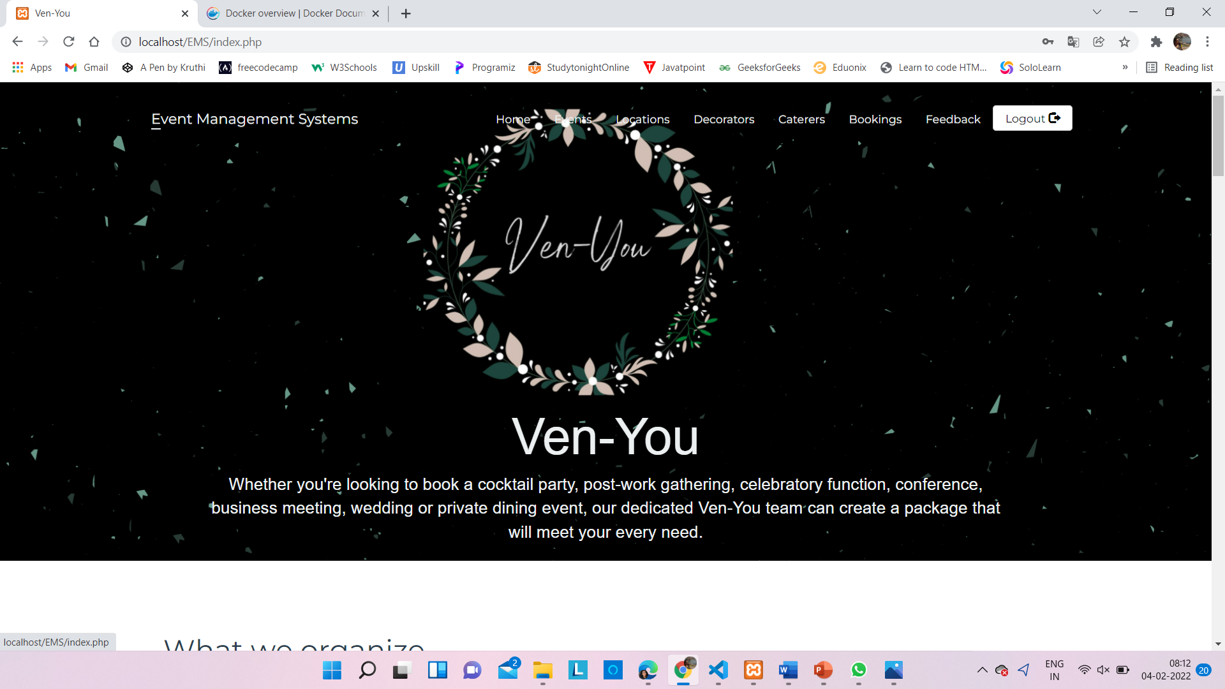

Fig 1.3.1 : Home page

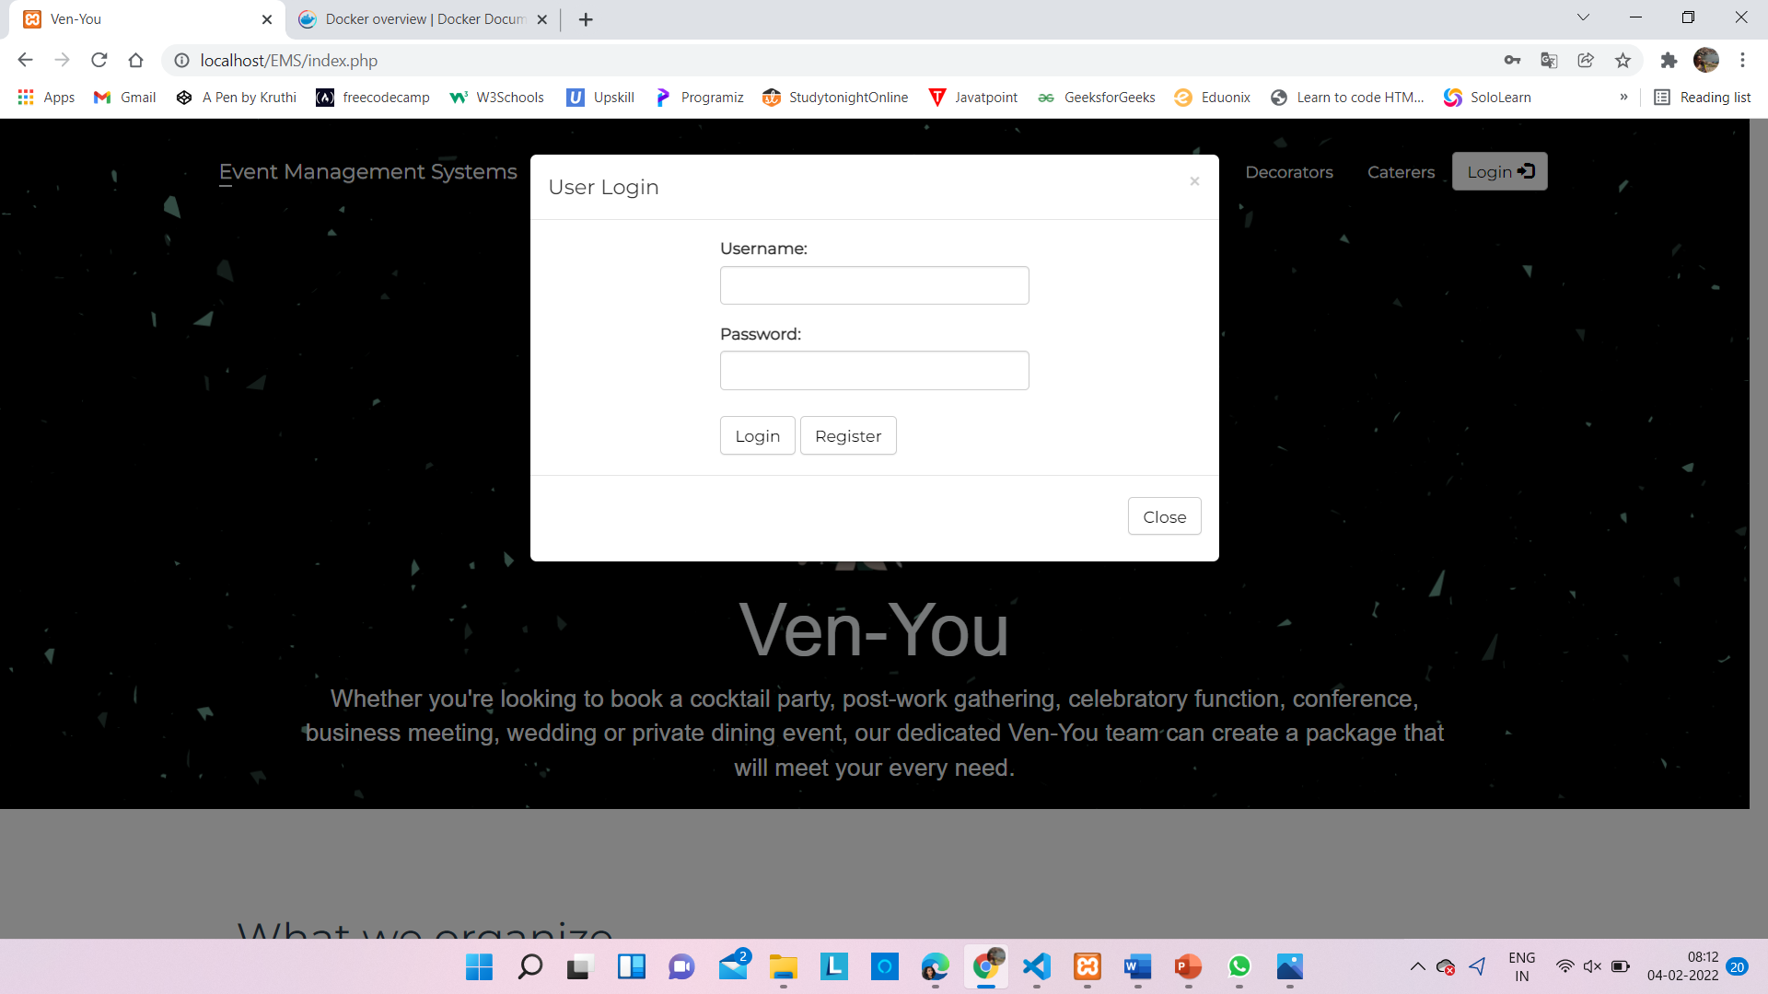

Fig 1.3.2 : Existing user login page

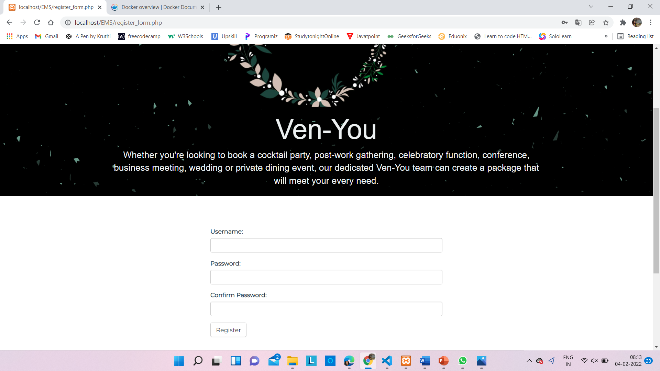

Fig 1.3.3 : New user registration page

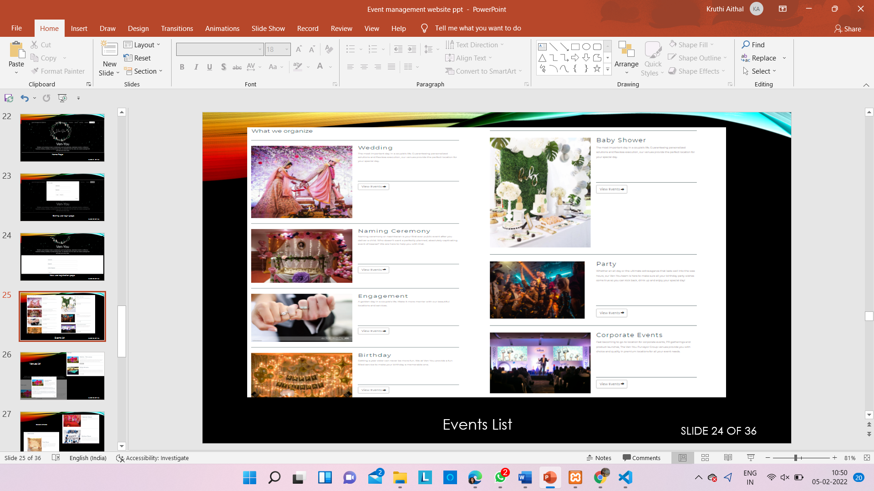

Fig 1.3.4 : Events list

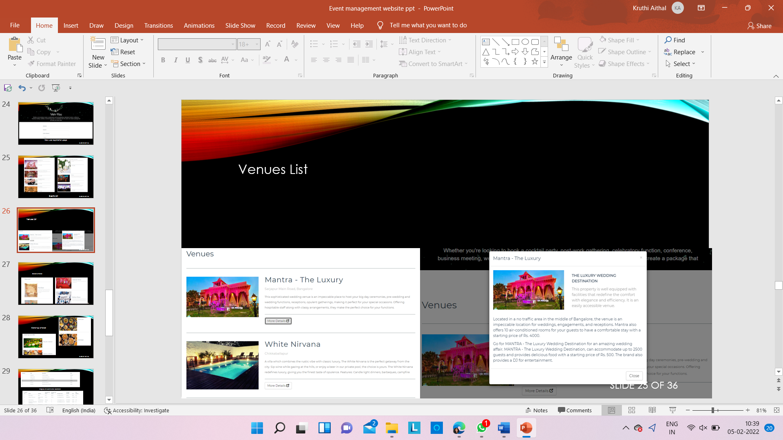

Fig 1.3.5 : List of venues

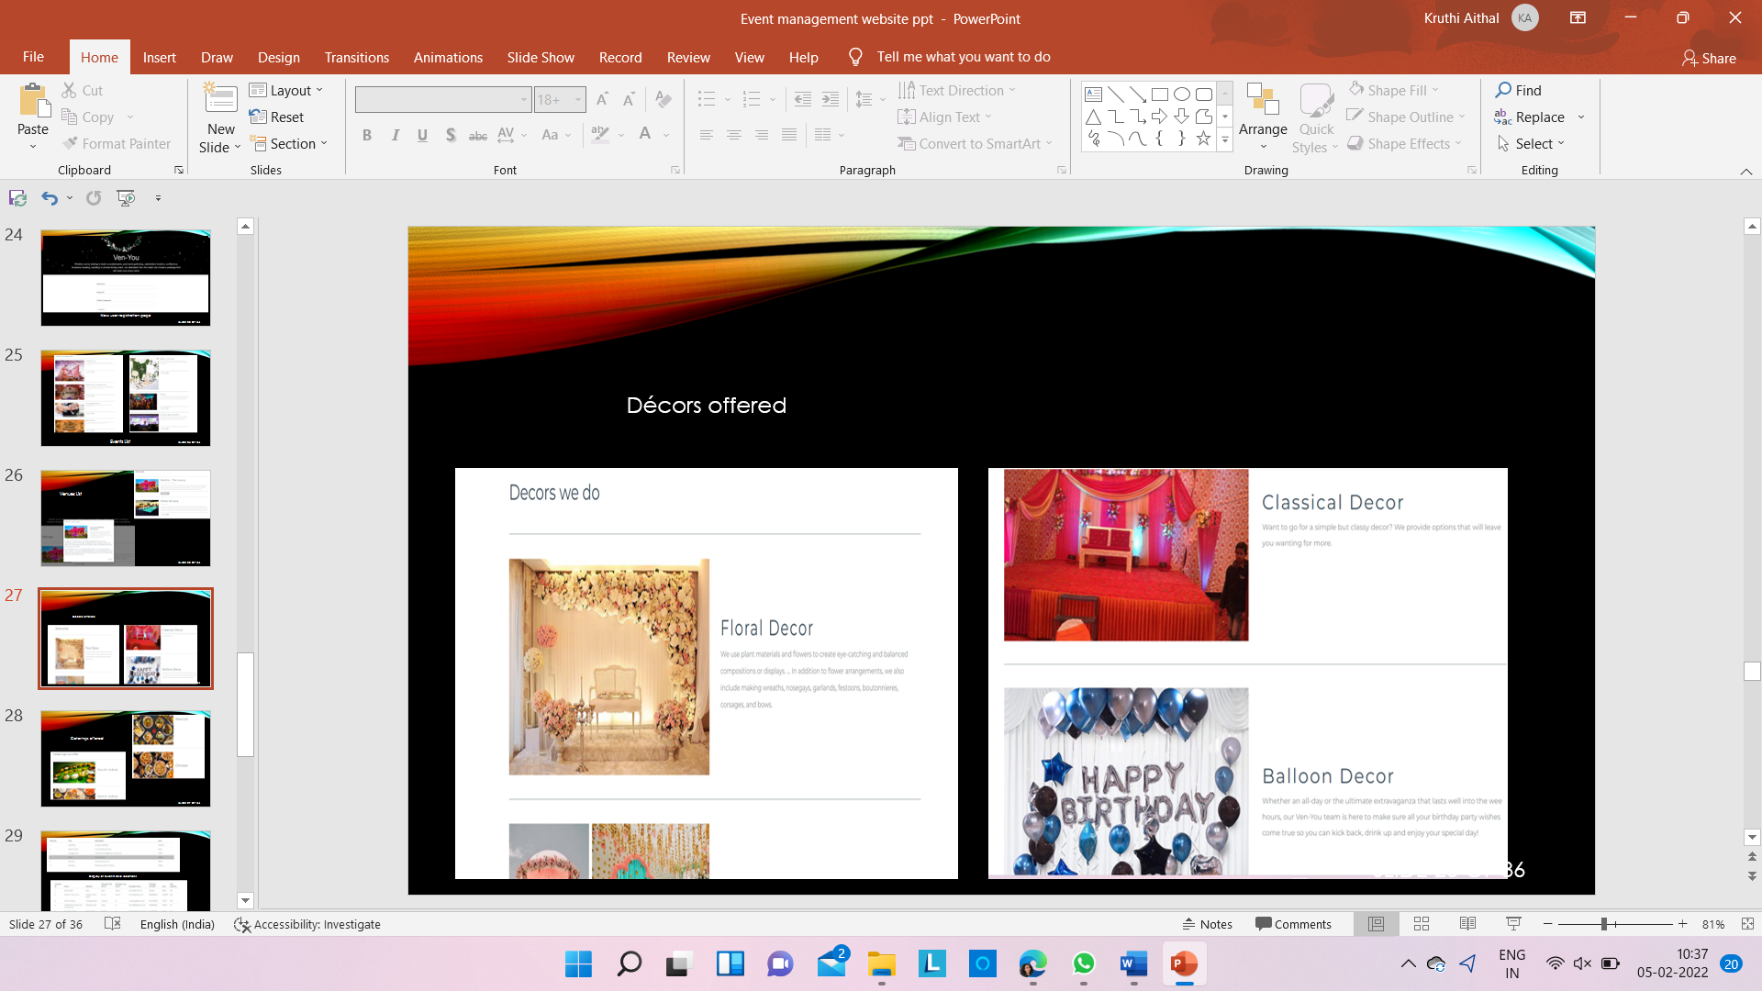

Fig 1.3.6 : List of decors

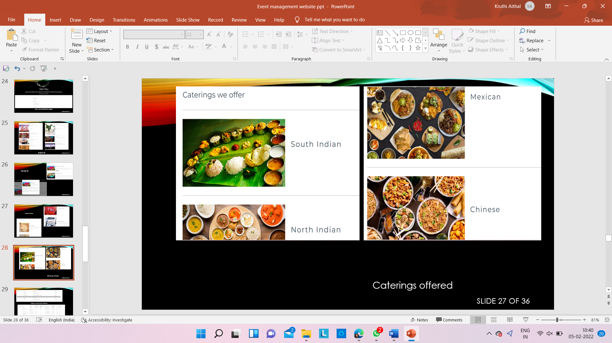

Fig 1.3.7 : List of Caterings

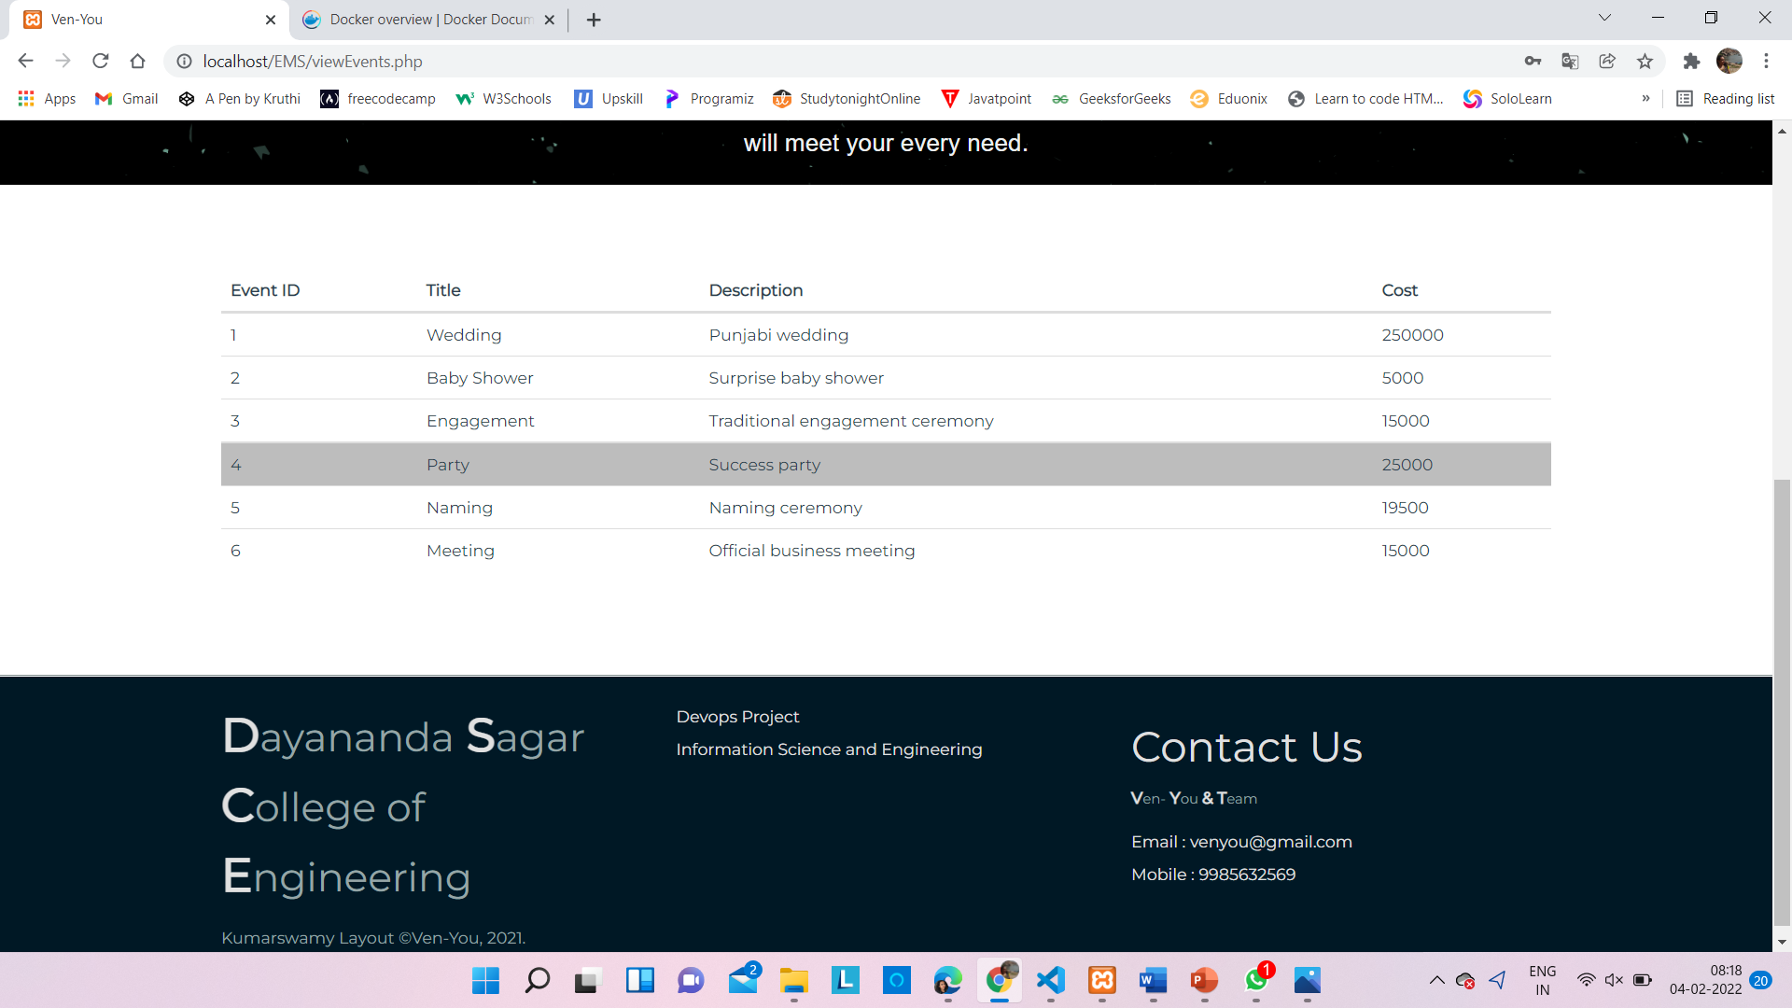

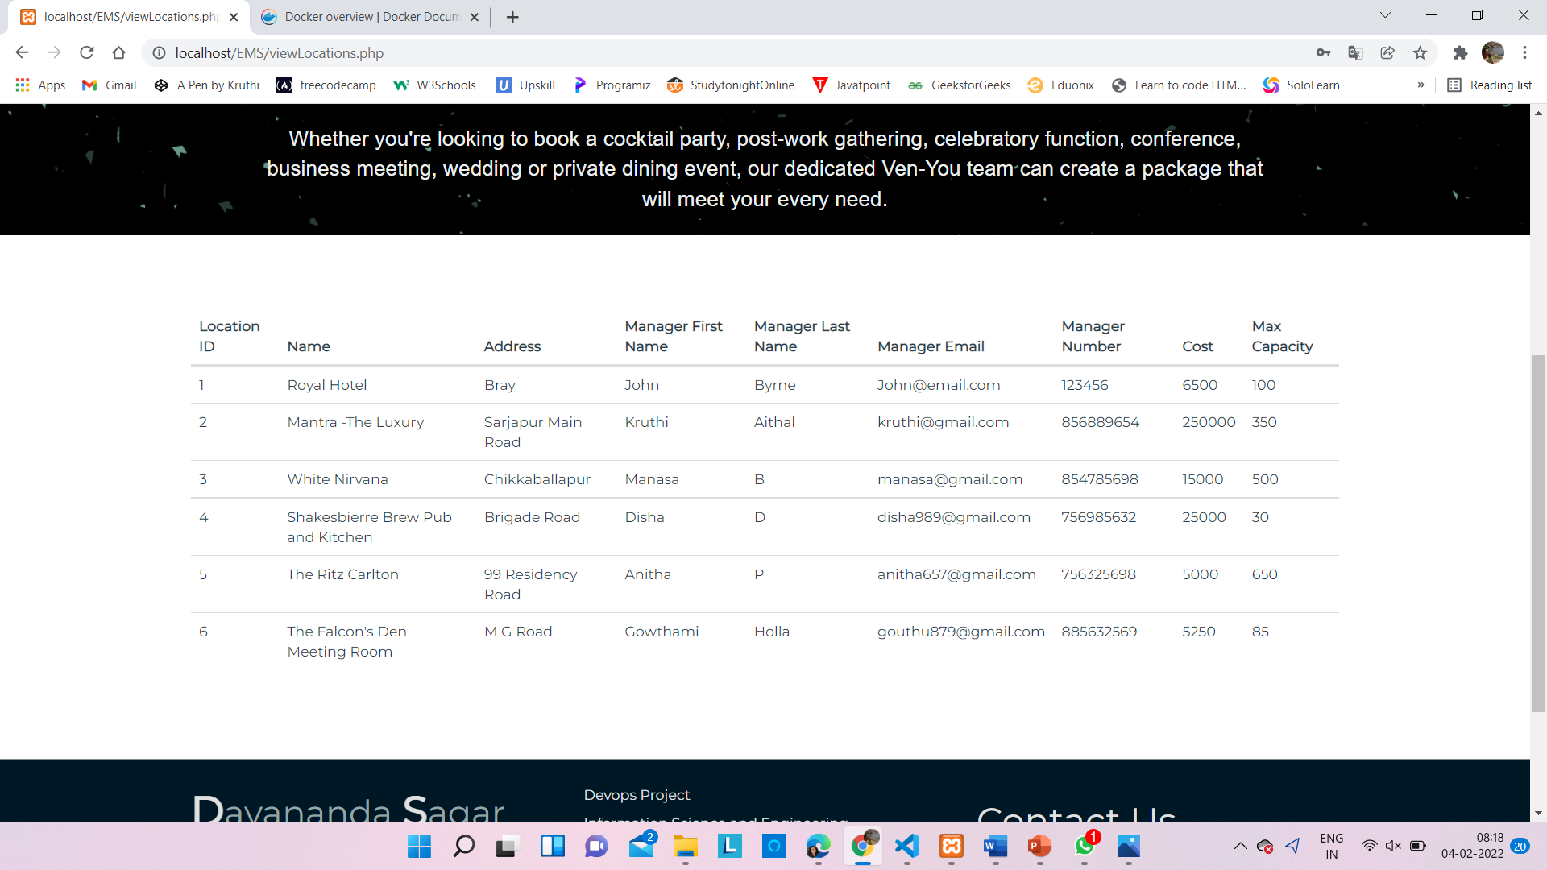

Fig 1.3.8 : Display of events and locations

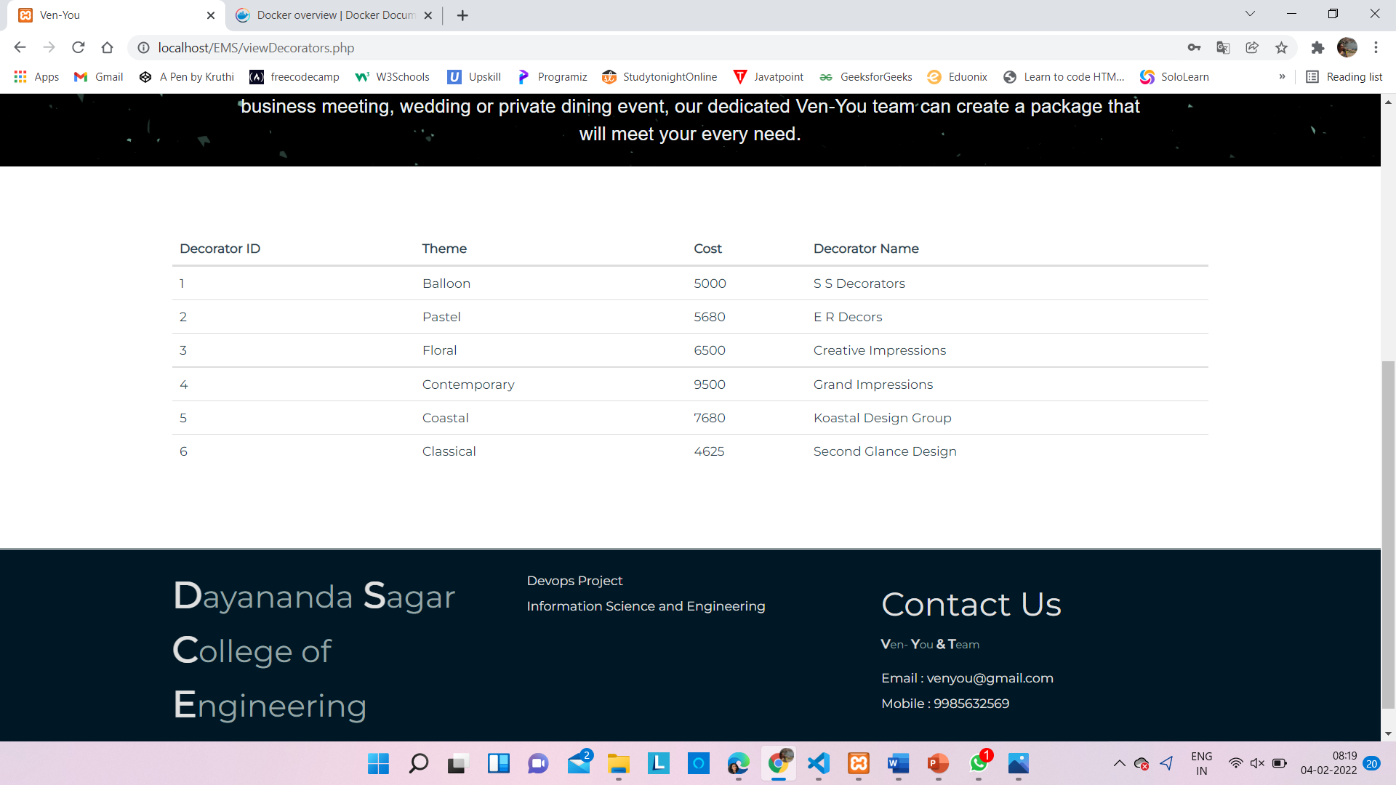

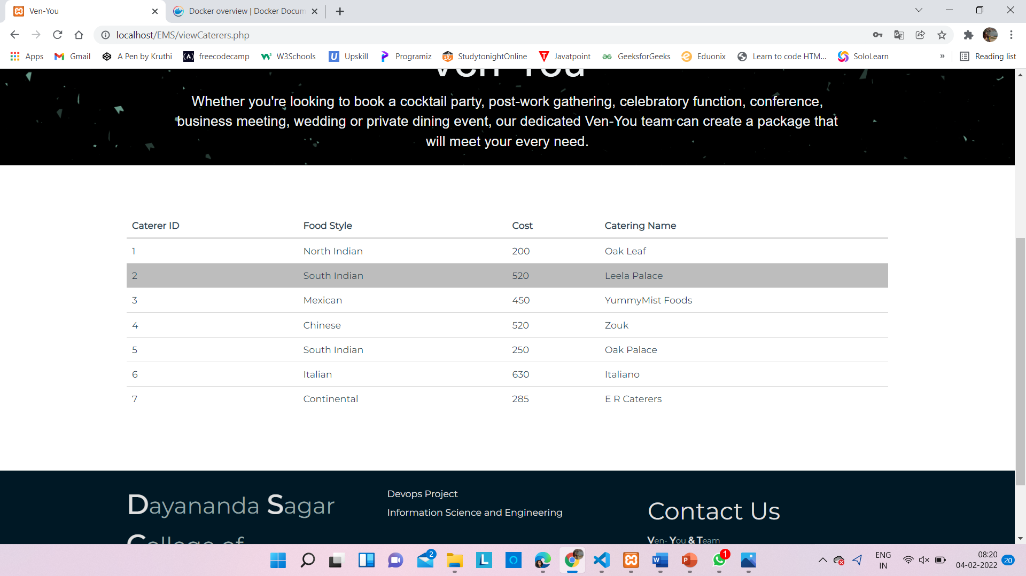

Fig 1.3.9 : Decorators and caterers information

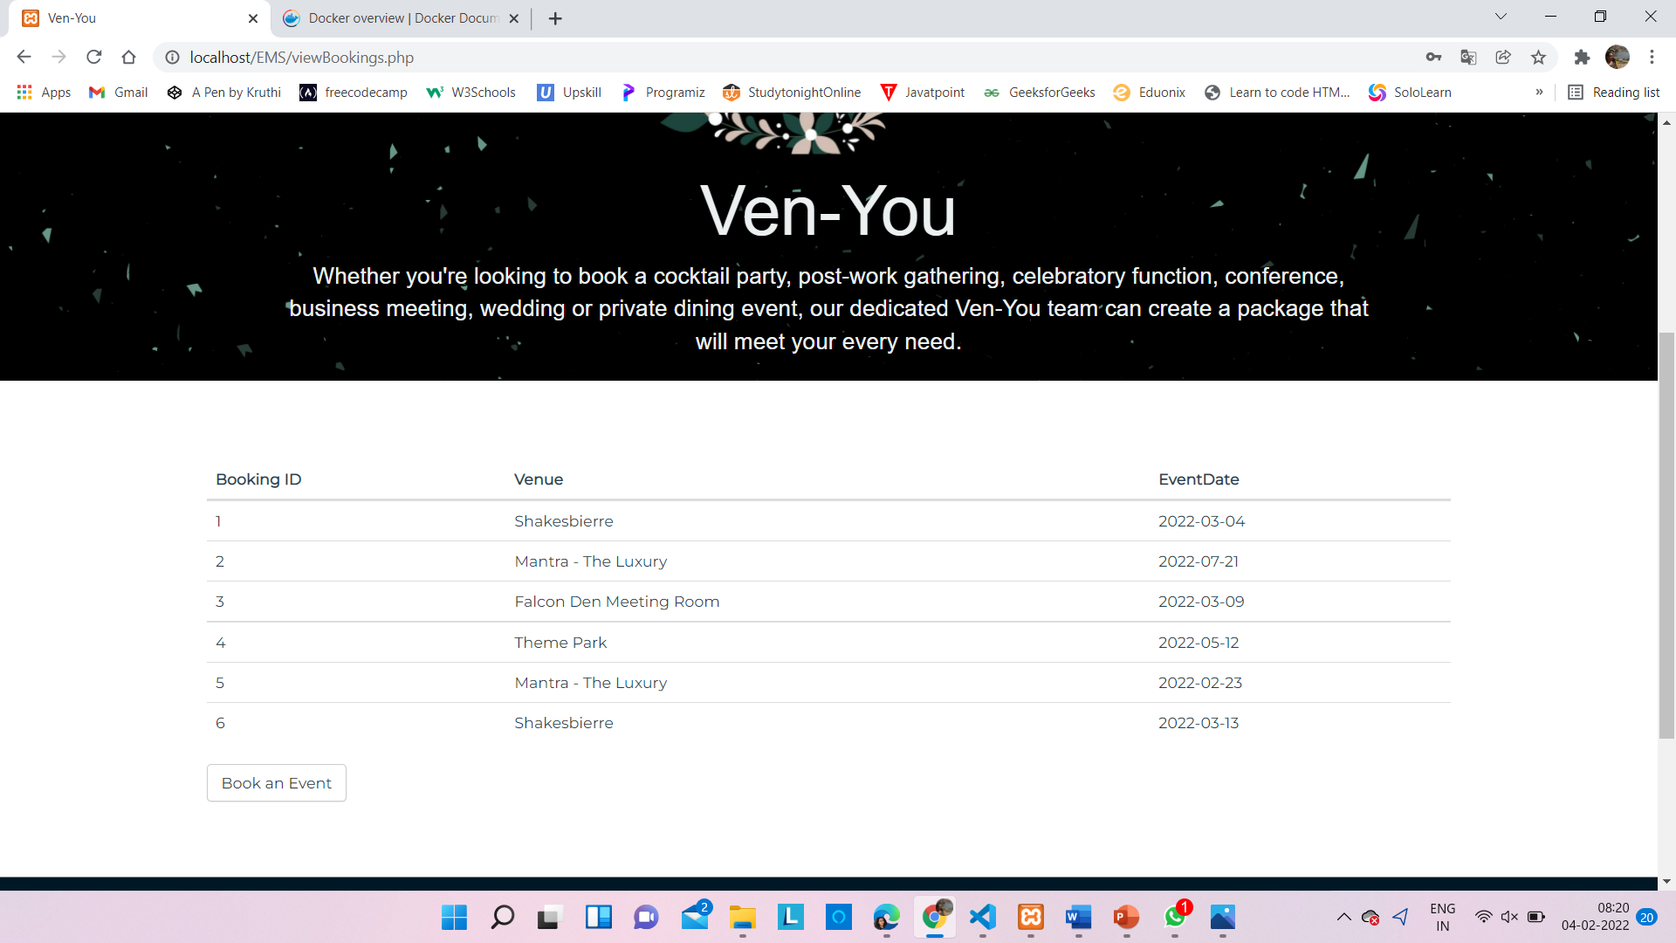

Fig 1.3.10 : Booking list

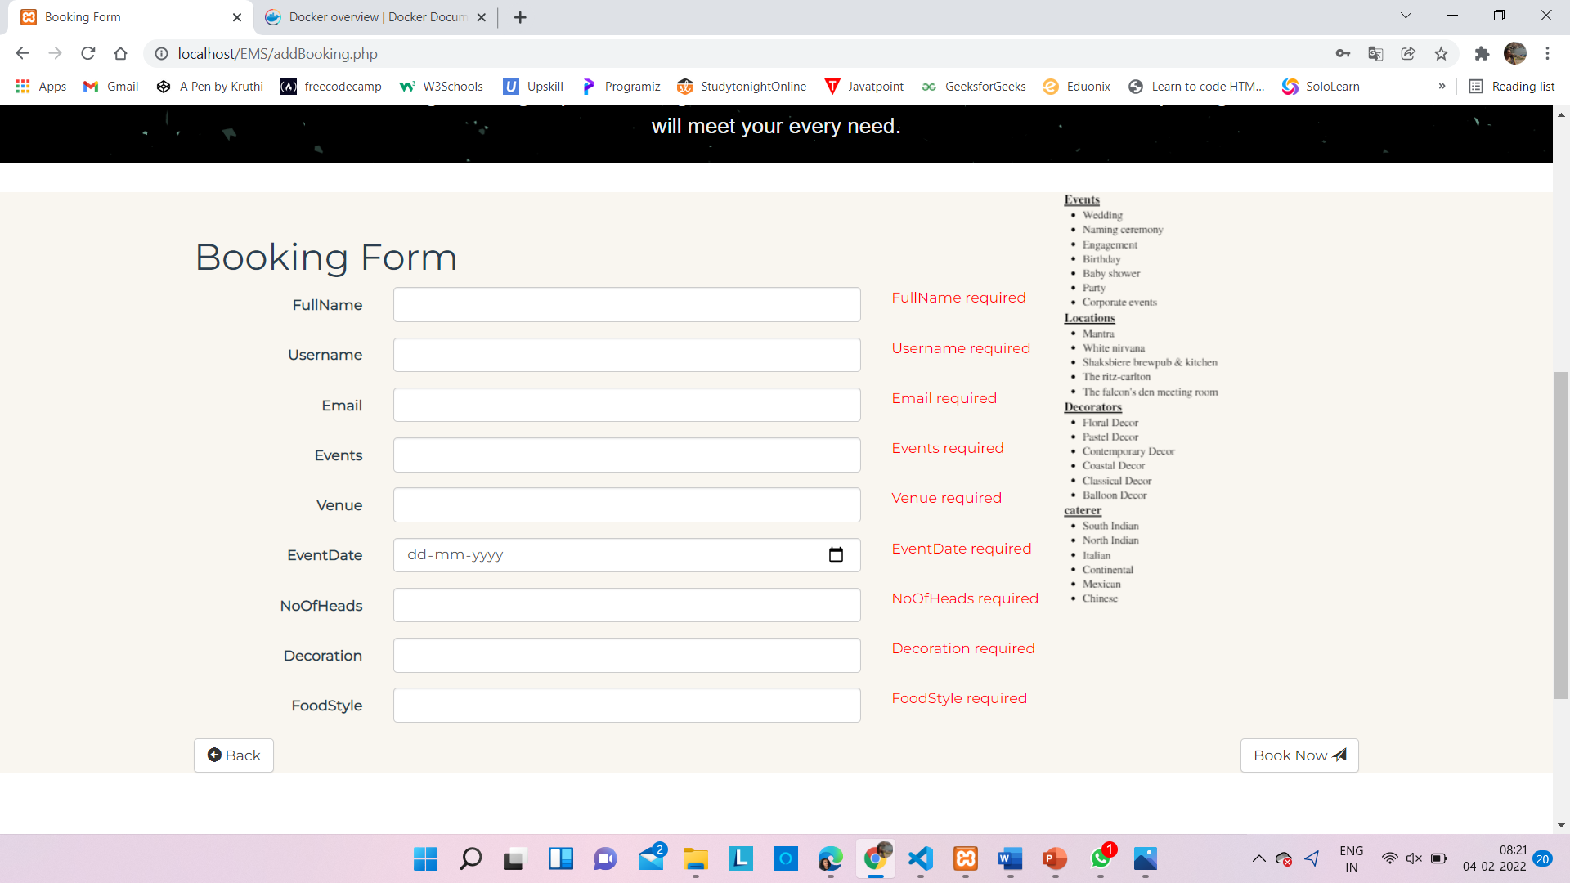

Fig 1.3.11 : Booking form

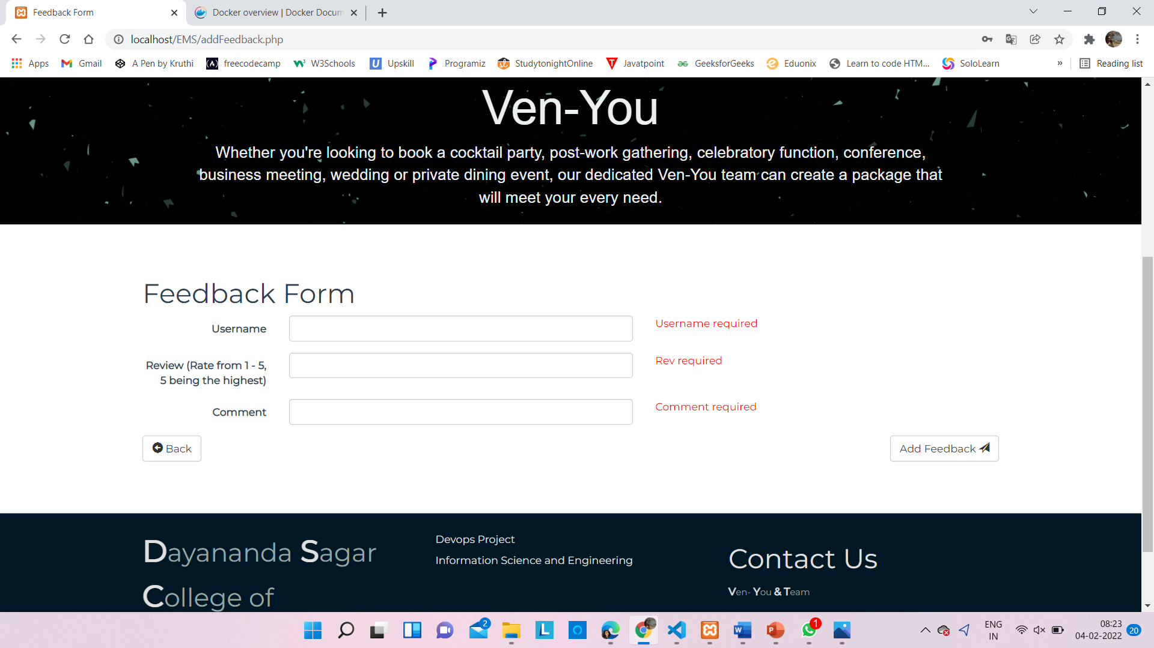

Fig 1.3.12 : Feedback form

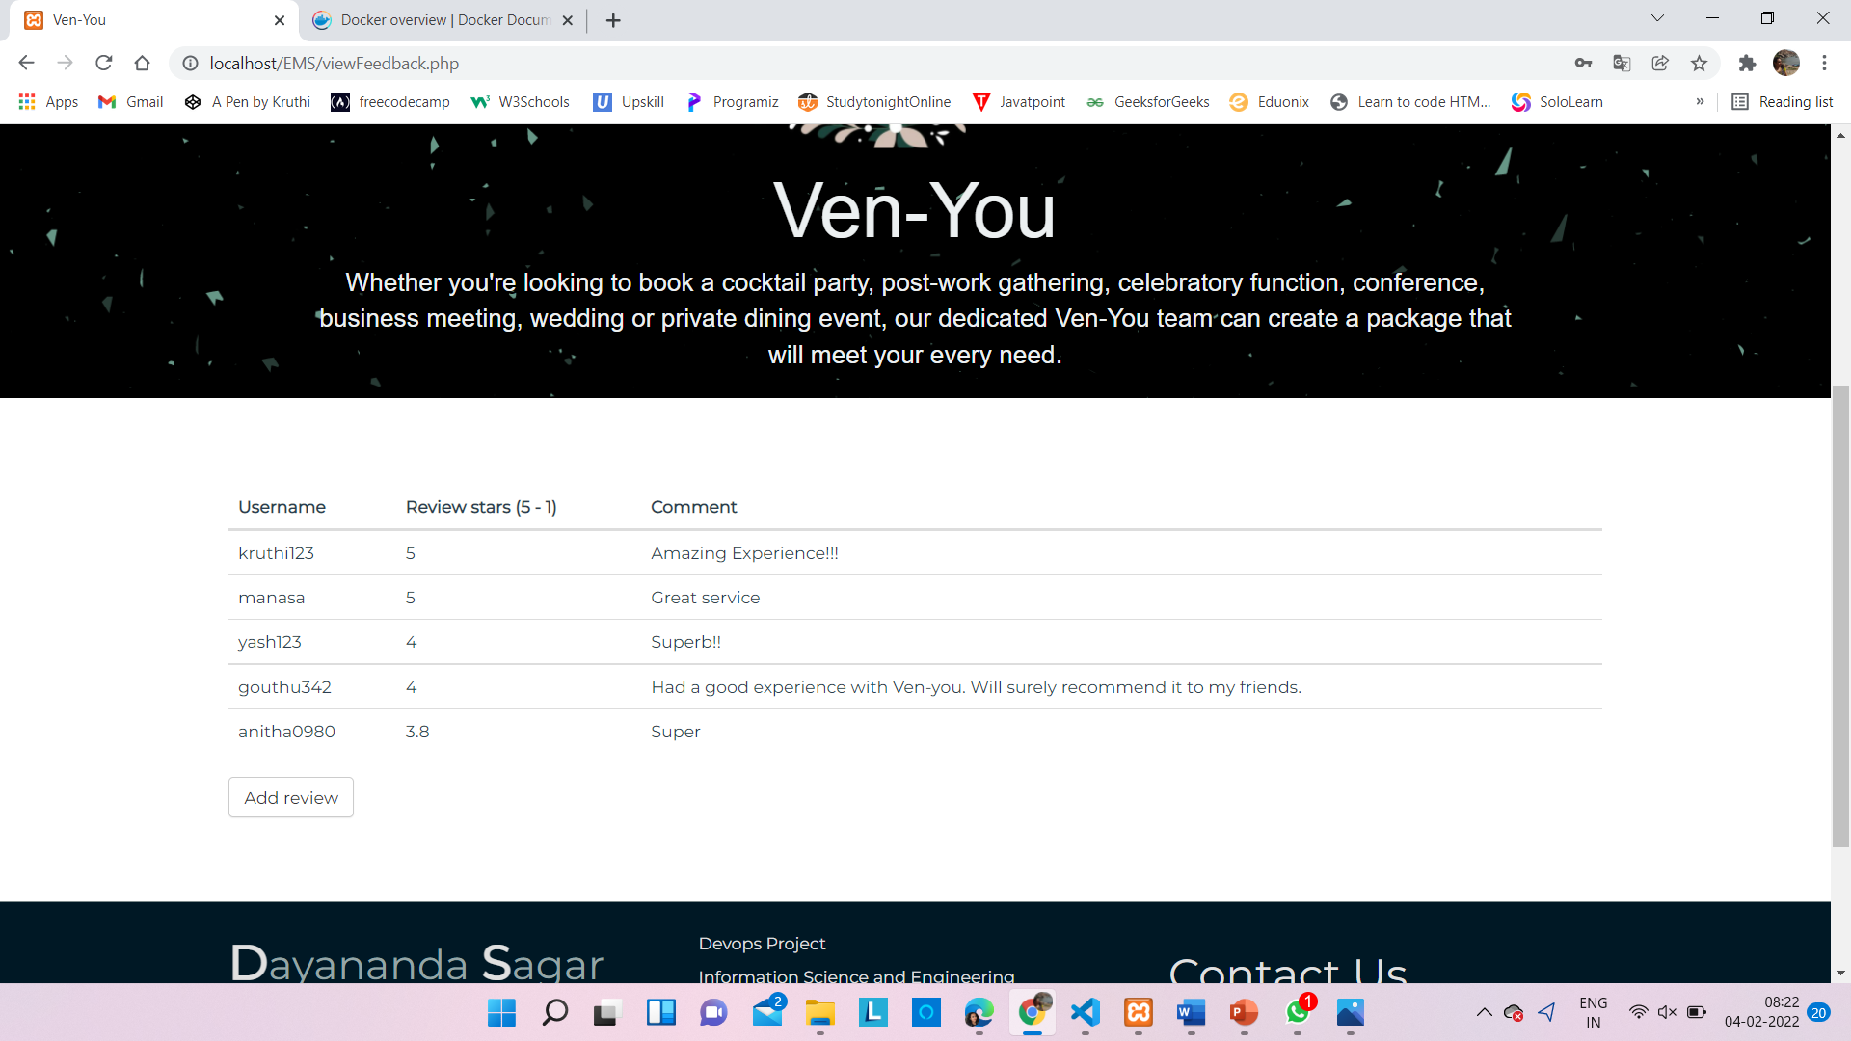

Fig 1.3.13 : Display of review by other users

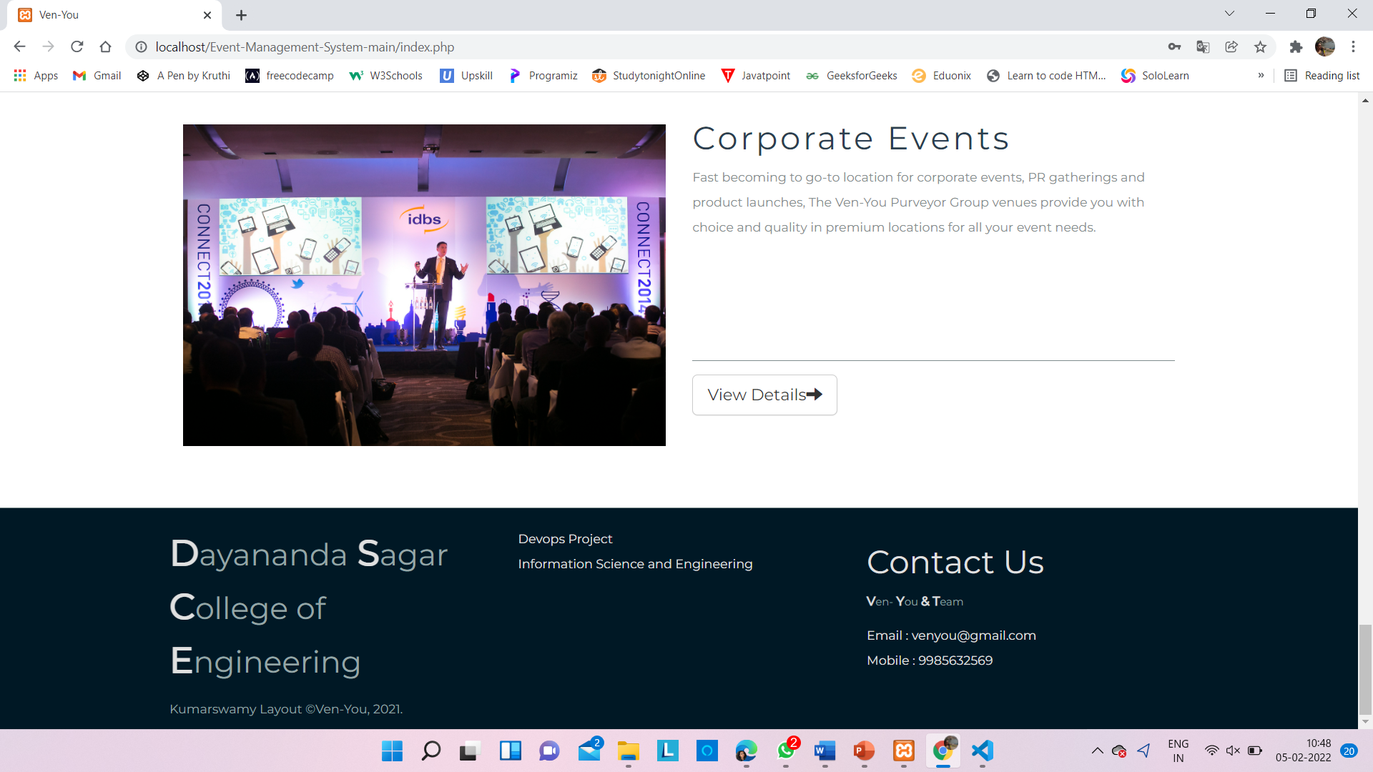

Fig 1.3.14 : Contact details

**1.4 Name of the Scrum Master and Product owner and team members**

Scrum Master : Kruthi R Aithal

Product Owner : Disha D

Team members :

Aishwarya J Annigeri

Akriti Kumari

Anitha P

Apoorva S V

Avani K S

Gowthami Holla K S

Manasa B

**1.5 Names of the members along with DevOps tools responsibility**

* **Version Control Tools** – *Git and GitHub*

Sub Team handling the tool : Anitha P, Disha D, Kruthi R Aithal

* **CI/Deployment Tool** - *Jenkins*

Sub Team handling the tool : Aishwarya J Annigeri , Akriti Kumari

* **Testing Tool** – *Selenium*

Sub Team handling the tool : Apoorva S V , Manasa B

* **Container Management Tool** - *Docker*

Sub Team handling the tool : Avani K , Gowthami Holla K S

**2. DEVOPS**

**2.1 DevOps Introduction**

DevOps (development and operations) is a collection of tools and technologies combined to carry out various business processes. It aims to bridge the gap between two of the most significant departments in any IT organization, the development department, and the operations department.

DevOps is not a tool or a team, it is the process or a methodology of using various tools to solve the problems between Developers and Operations team, hence the term “Dev-Ops”

The development team always had the pressure of completing the old, pending work that was considered faulty by the operations team. With DevOps, there is no wait time to deploy the code and get it tested. Hence, the developer gets instantaneous feedback on the code, and therefore can close the bugs, and can make the code production ready faster!

It is a philosophy that encourages adopting iterative software development, automation, and programmable infrastructure deployment and maintenance.

DevOps emphasizes building trust and better liasion between developers and system administrators. This helps the organization in aligning technological projects to business requirements. Changes rolled out are usually small and reversible, which the entire team begins to comprehend.

**2.2 How DevOps Works :**

DevOps is the practice of operations and development engineers that work together in the entire project lifecycle, from design and development process to production releases and support.

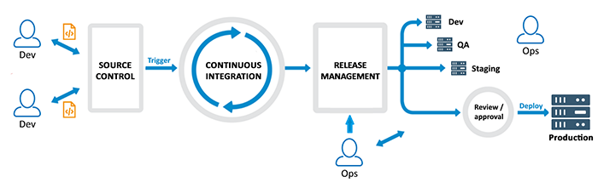

Fig 2.2.1 : Working of DevOps

Starting from design and development to testing automation and from continuous integration to continuous delivery, the team works together to achieve the desired goal. People having both development and operations skill sets working together and use various tools for CI-CD and Monitoring to respond quickly to customers need and fix issues and bugs.

DevOps works by automating tasks. This includes things like [Continuous Integration](https://www.perforce.com/blog/kw/what-continuous-integration), [Continuous Delivery](https://www.perfecto.io/blog/keys-to-strong-ci-cd-pipeline), and [Continuous Testing](https://www.perfecto.io/continuous-testing). Ensuring an efficient [CI/CD pipeline](https://www.perforce.com/blog/kw/static-analysis-ci-cd-pipelines) is particularly important. A successful [DevOps team](https://www.perforce.com/blog/vcs/version-control-best-practices-affect-your-devops-challenges) must be organized, work together, and adhere to best practices to envision, plan, develop, build, deploy, and validate.

Under a DevOps model, development and operations teams are no longer “siloed.” Sometimes, these two teams are merged into a single team where the engineers work across the entire application lifecycle, from development and test to deployment to operations, and develop a range of skills not limited to a single function.

In some DevOps models, quality assurance and security teams may also become more tightly integrated with development and operations and throughout the application lifecycle. When security is the focus of everyone on a DevOps team, this is sometimes referred to as DevSecOps. These teams use practices to automate processes that historically have been manual and slow. They use a technology stack and tooling which help them operate and evolve applications quickly and reliably. These tools also help engineers independently accomplish tasks (for example, deploying code or provisioning infrastructure) that normally would have required help from other teams, and this further increases a team’s velocity.

**2.3 Benefits of DevOps**

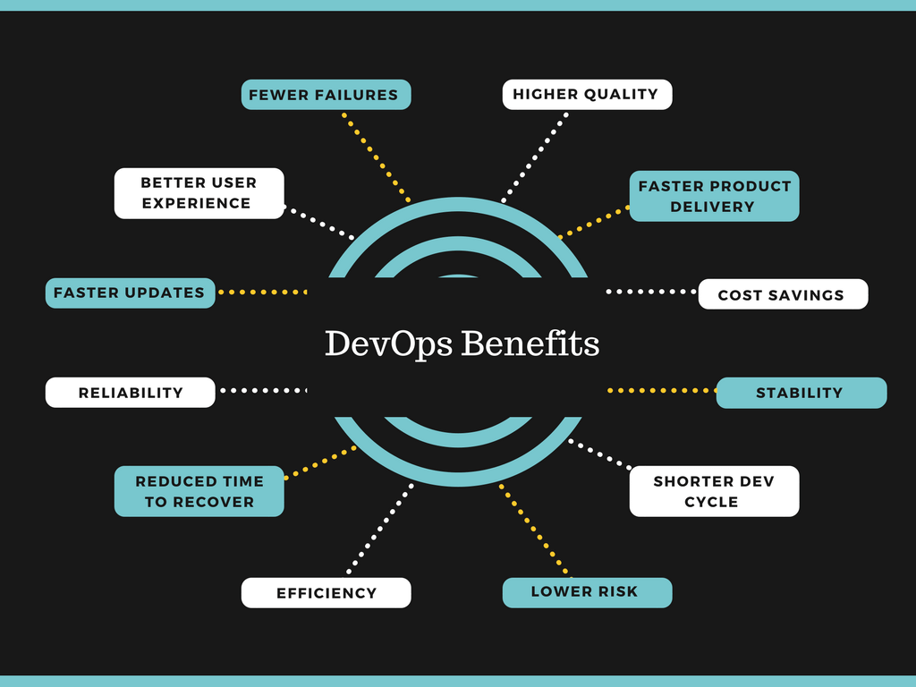

Fig 2.3.1 : Benefits of DevOps

### 1. Ensure faster deployment

Faster and more frequent delivery of updates and features will not only satisfy the customers but will also help your company take a firm stand in a competitive market.

**2. Stabilize work environment**

Do you know that the tension involved in the release of new features and fixes or updates can topple the stability of your workspace and decreases the overall productivity? Improve your work environment with a steady and well-balanced approach of operation with DevOps practice.

**3. Significant improvement in product quality**

Collaboration between development and operation teams and frequent capturing of user feedback leads to a significant improvement in the quality of the product.

**4. Automation in repetitive tasks leaves more room for innovation**

DevOps has greater benefits when compared to the traditional model as it helps in detecting and correcting problems quickly and efficiently. As the flaws are repeatedly tested through automation, the team gets more time in framing new ideas.

**5. Promotes agility in your business**

It’s no secret that making your business agile can help you to stay ahead in the market. Thanks to DevOps, it is now possible to obtain the scalability required to transform the business.

**6. Continuous delivery of software**

In DevOps methodology, all of the departments are responsible for maintaining stability and offering new features. Therefore, the speed of software delivery is fast and undisturbed, unlike the traditional method.

**7. Fast and reliable problem-solving techniques**

Ensuring quick and stable solution to technical errors in software management is one of the primary benefits of DevOps.

**8. Transparency leads to high productivity**

With the elimination of silo(ing) and promotion of collaboration, this process allows for easy communication among the team members, making them more focused in their specialised field. Therefore, incorporating DevOps practices has also led to an upsurge in productivity and efficiency among the employees of a company.

**9. Minimal cost of production**

With proper collaboration, DevOps helps in cutting down the management and production costs of your departments, as both maintenance and new updates are brought under a broader single umbrella.

.

**3. DEVOPS TOOLS**

**3.1 DevOps Tools used**

Version Control Tool : Git & GitHub

CI/Deployment Tool : Jenkins

Testing Tool : Selenium

Container Management Tool :Docker

**3.2 Benefits of each DevOps Tool**

**3.2.1 Git and GitHub**

* Git is a version control system that lets us manage and keep track

of our source code history.

* GitHub is a cloud-based hosting service that lets us manage Git repositories.

If there are open-source projects that use Git, then GitHub is designed

to help in managing them.

Benefits :

1. Easier to contribute to open source projects
2. Documentation
3. Showcase your work
4. Track changes in your code across versions.
5. Integrate options

**3.2.2 Jenkins**

Jenkins is an open-source server that is written entirely in Java. It lets you execute a series of actions to achieve the continuous integration process, that too in an automated fashion.

Benefits :

* It is an open-source tool with great community support.
* It is easy to install.
* It has 1000+ plugins to ease your work.
* It is free of cost.
* It is built with Java and hence, it is portable to all the major platforms.

**3.2.3 Selenium**

Selenium is an open-source tool that automates web browsers. It provides a single interface that lets you write test scripts in various programming languages. IT professionals use Selenium to test web applications. Developers can write test scripts in several programming languages within Selenium, including Java and Python, and it's compatible with any web browser and operating system. When integrated with Jenkins and Docker, developers can achieve continuous web application testing.

Benefits :

1. Open source software
2. Supports multiple programming languages
3. Supports almost every OS
4. Supports parallel test execution
5. Supports multiple browsers
6. Provides support for frameworks.

**3.2.4 Docker**

Docker is an open platform for developing, shipping, and running applications. Docker enables you to separate your applications from your infrastructure so you can deliver software quickly. With Docker, you can manage your infrastructure in the same ways you manage your applications.

Benefits :

1. Portability and flexibility
2. Increased productivity
3. Multi cloud capacity
4. Open source

**4. IMPLEMENTATION OF DEVOPS TOOLS FOR VERSION MANAGEMENT**

**4.1 What is configuration management**

Configuration management occurs when a configuration platform is used to automate, monitor, design and manage otherwise manual configuration processes. System-wide changes take place across servers and networks, storage, applications, and [other managed systems](https://puppet.com/resources/whitepaper/get-started-devops-guide-it-managers).

An important function of configuration management is defining the state of each system. By orchestrating these processes with a platform, organizations can ensure consistency across integrated systems and increase efficiency. The result is that businesses can scale more readily without hiring additional IT management staff. Companies that otherwise wouldn’t have the resources can grow by deploying a DevOps approach.

Configuration management is closely associated with change management, and as a result, the two terms are sometimes confused. Configuration management is most readily described as the automation, management, and maintenance of configurations at each state, while change management is the process by which configurations are redefined and changed to meet the conditions of new needs and dynamic circumstances.

**4.2 Tools implemented**

**Git:** Git is a distributed version control system for tracking changes in source code during software development. It is designed for coordinating work among programmers, but it can be used to track changes in any set of files. Its goals include speed, data integrity, and support for distributed, non-linear workflows. Git is a version control system that lets you manage and keep track of your source code history.

**GitHub:** GitHub is a web-based Git repository hosting service, which offers all of the distributed revision control and source code management (SCM) functionality of Git as well as adding its own features. GitHub is a cloud-based hosting service that lets you manage Git repositories. If you have open-source projects that use Git, then GitHub is designed to help you better manage them.

**4.3 Version management/branching strategy**

A “branching strategy” refers to the strategy a software development team employs when writing, merging, and shipping code in the context of a version control system like Git. Software developers working as a team on the same codebase must share their changes with each other. But how can they do this efficiently while avoiding malfunctions in their application? The goal of any branching strategy is to solve that problem and to enable teams to work together on the same source code without trampling on each other. A branching strategy defines how a team uses branches to achieve this level of concurrent development.

Simply put, a branching strategy is something a [software development team](https://www.bmc.com/blogs/it-teams/) uses when interacting with a version control system for writing and managing code. As the name suggests, the branching strategy focuses on how branches are used in the development process.

A branching strategy ensures everyone on the team is following the same process for making changes to source control. The right strategy enhances collaboration, efficiency, and accuracy in the software delivery process, while the wrong strategy (or no strategy) leads to hours of lost effort One major purpose of a version control system is to enable a collaborative development environment without overlapping or affecting the codebase. There, each team member modifying the same source code will inevitably be making conflicting code changes. However, we can avoid such conflicts with a version control system by using branches when writing and merging code to a master branch to create the end product.

* 1. **List of software artefacts covered in version management tool**
* Git tool installed in the individual systems
* Versions building
* Multiple contributors to the same code present in GitHub
* GitBash code to edit the code
* An additional GitHub plugin on VS code
* Pull and push requests to GitHub through GitBash
* Creating branches and managing different versions of the code
* Merging codes in GitHub

**4.5 Features of the tools implemented**

* **Non-linear Development:**  
  Git allows users from all over the world to perform operations on a project remotely. A user can pick up any part of the project and do the required operation and then further update the project. This can be done by the Non-linear development behavior of the Git. Git supports rapid branching and merging and includes specific tools for visualizing and navigating a non-linear development history.
* **Branching:**  
  Git allows its users to work on a line that runs parallel to the main project files. These lines are called branches. Branches in Git provide a feature to make changes in the project without affecting the original version.  The master branch of a version will always contain the production quality code.
* **Open-Source:**

It is called open-source because it provides the flexibility to modify its source code according to the user’s needs.

* **Speed:**

Since Git stores all the data related to a project in the local repository by the process of cloning, it is very much efficient to fetch data from the local repository instead of doing the same from the remote repository.

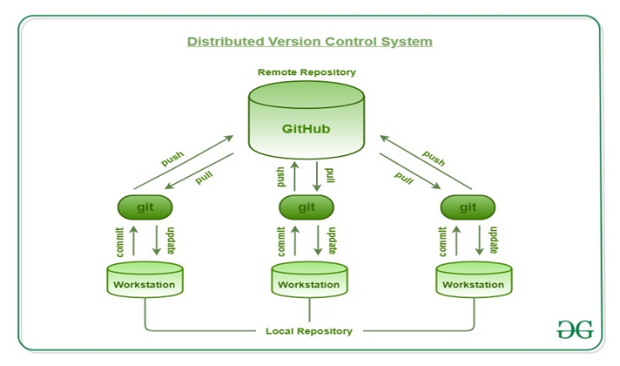

Fig 4.5.1 : Distributed Version control system

* 1. **Benefits derived**
* Easy duplication of code without much waste of time.
* Multiple contributors
* Errors can be debugged easily
* Team works at the same time from different places
* Cloud storage
* Additional Projects section to discuss the work flow.

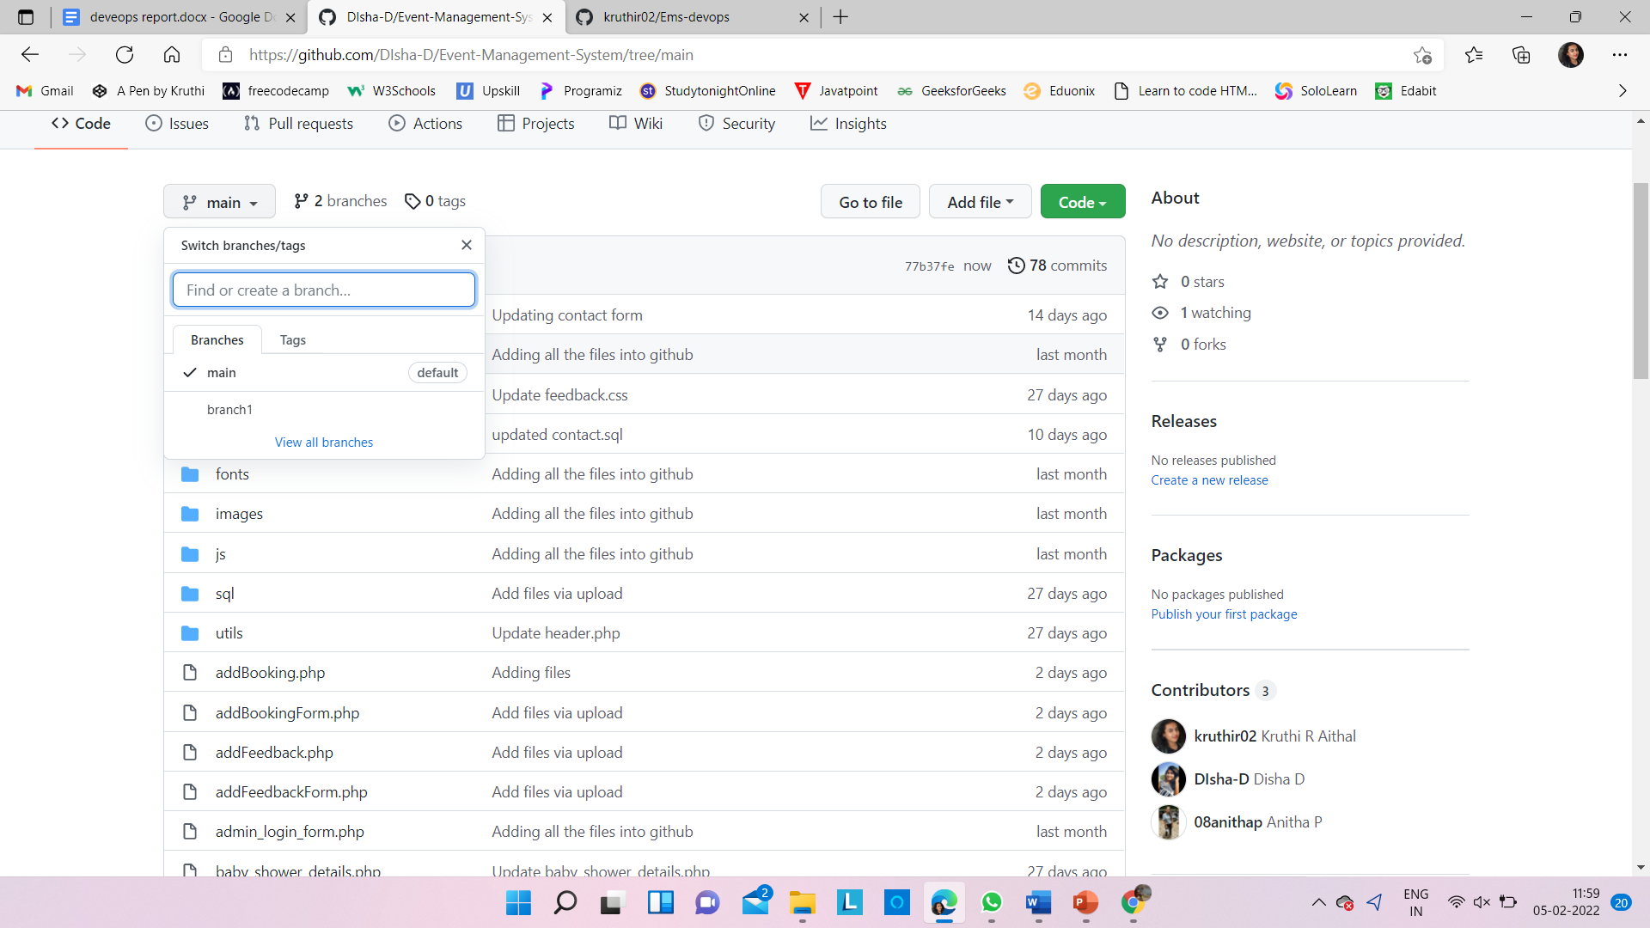 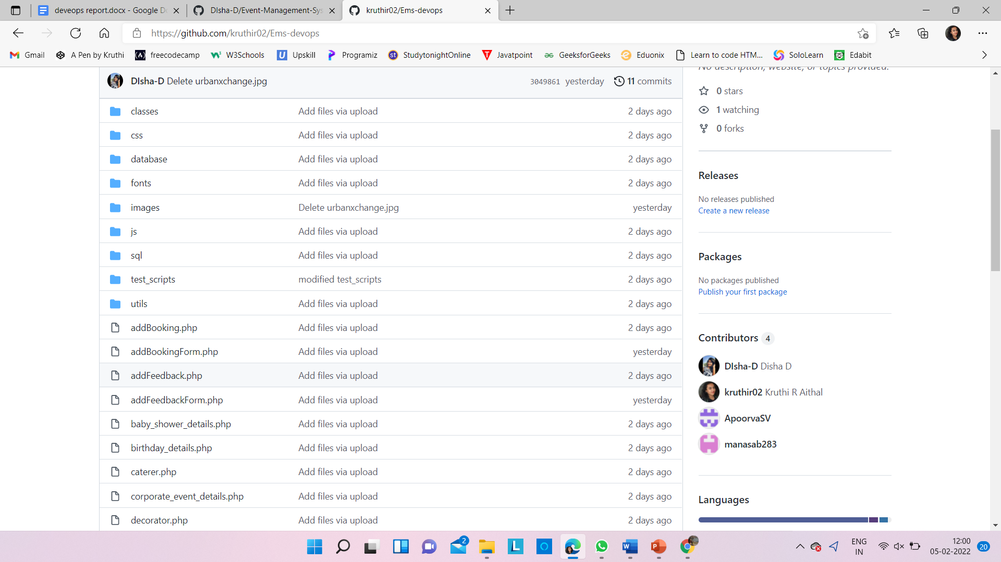

Fig 4.5.1 : Branches and contributors

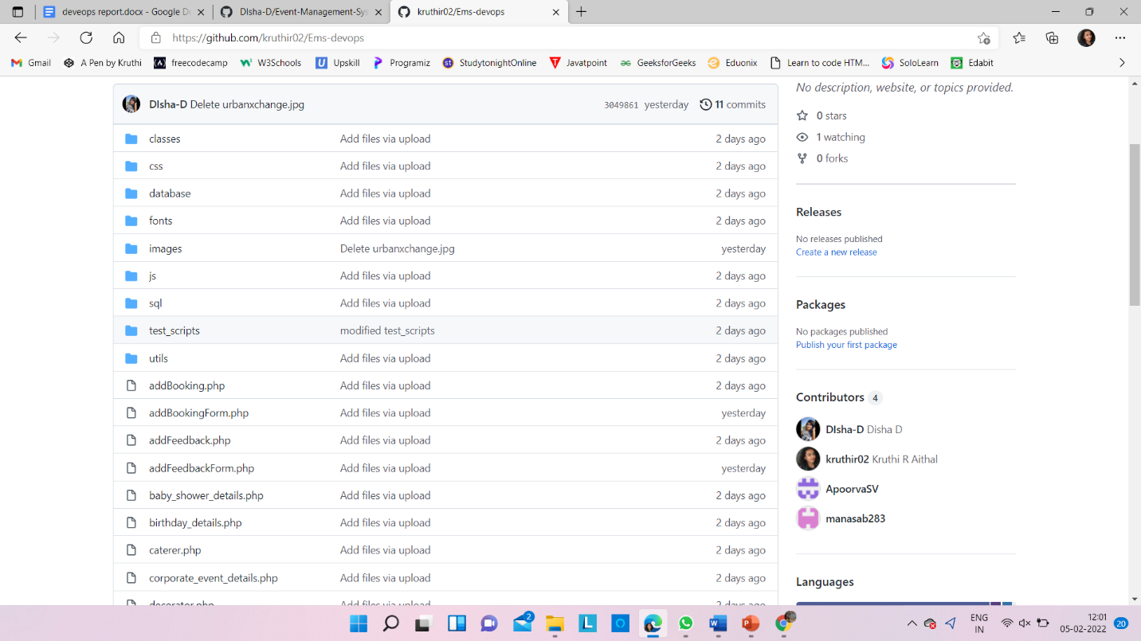

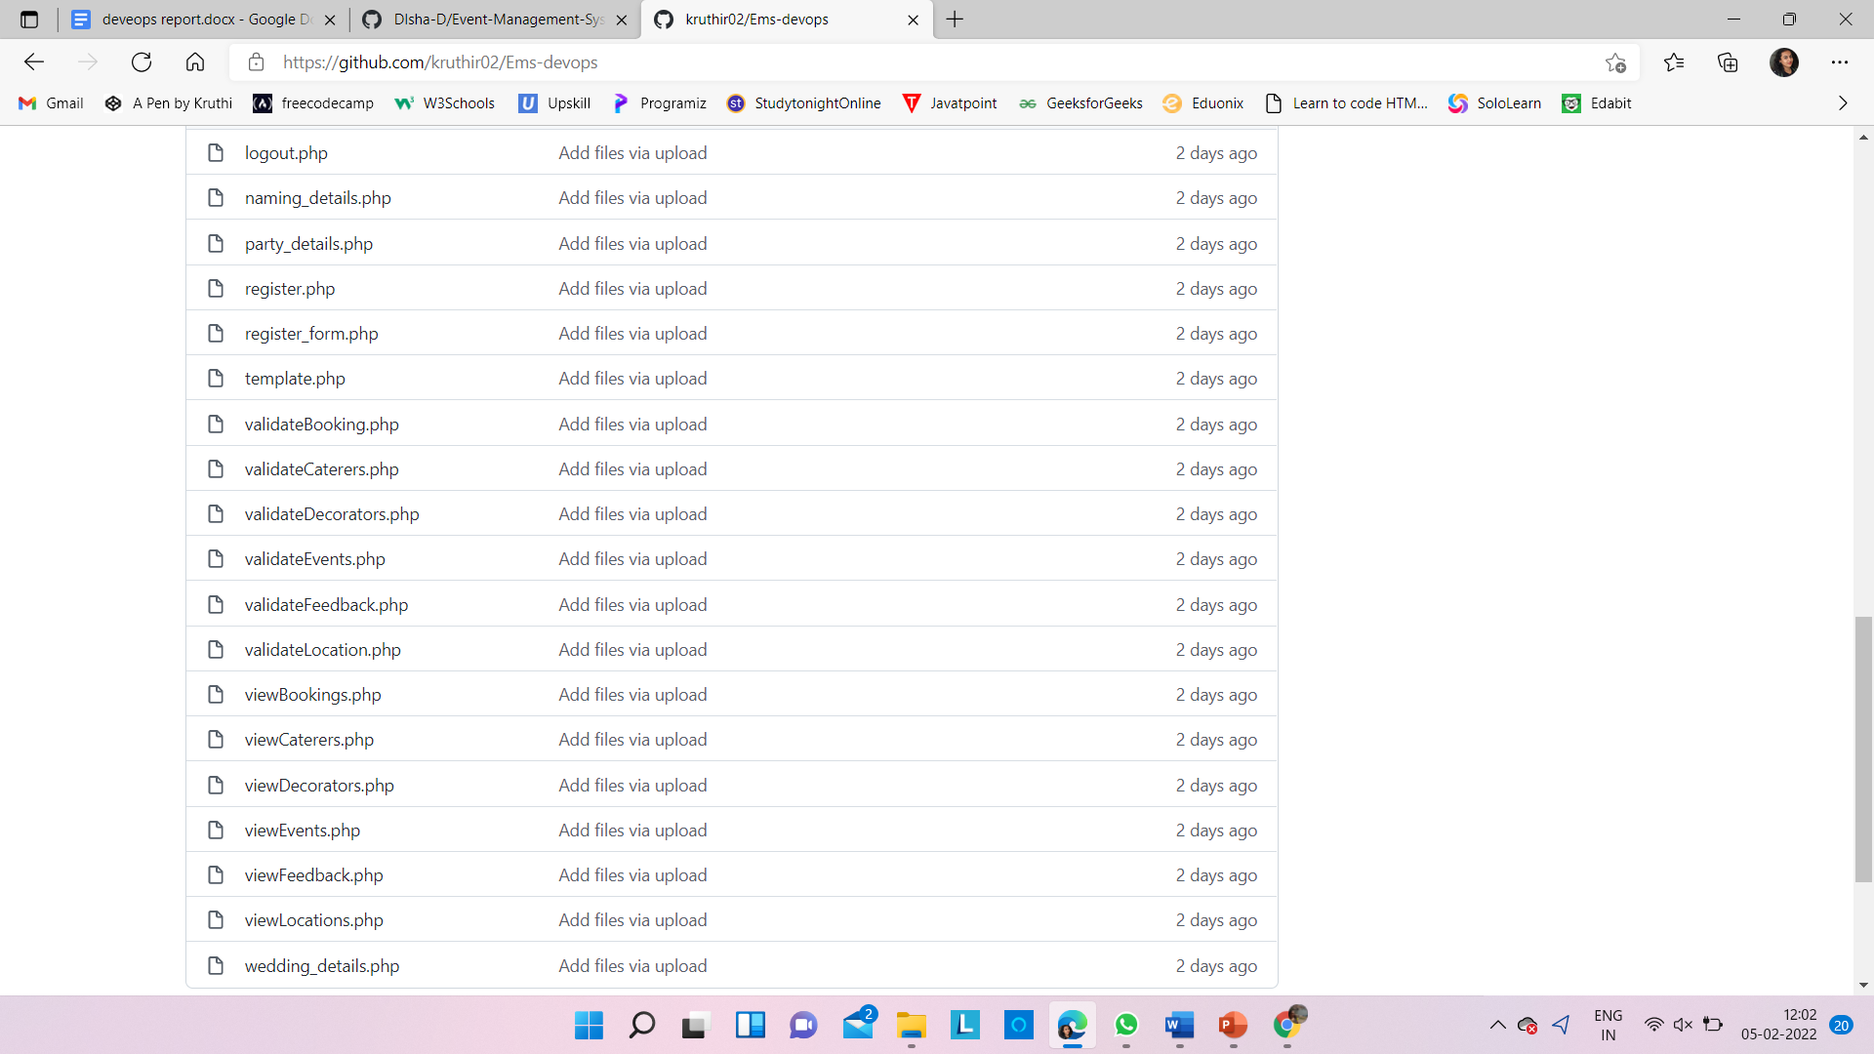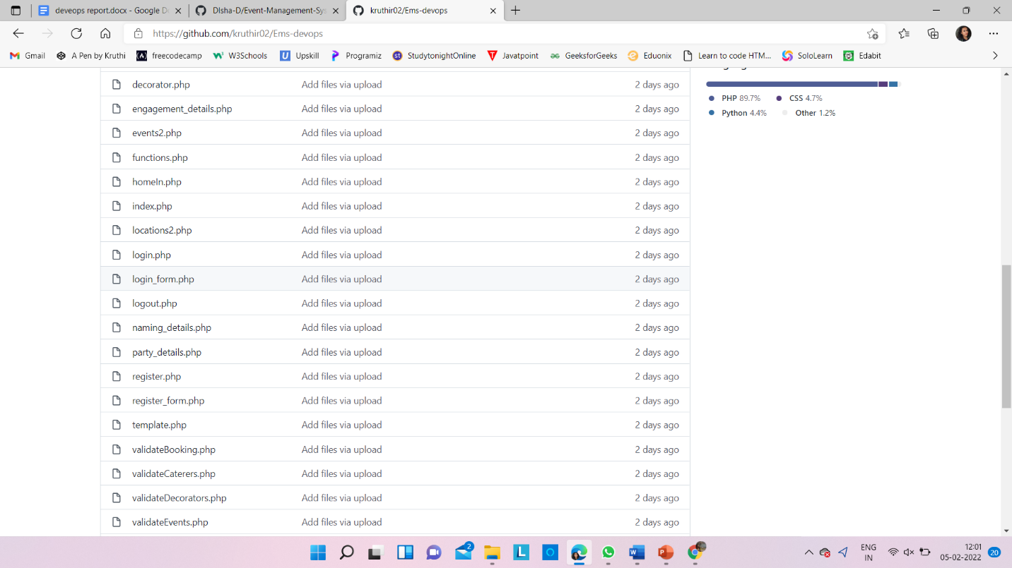

Fig 4.5.2 : Pushed code files

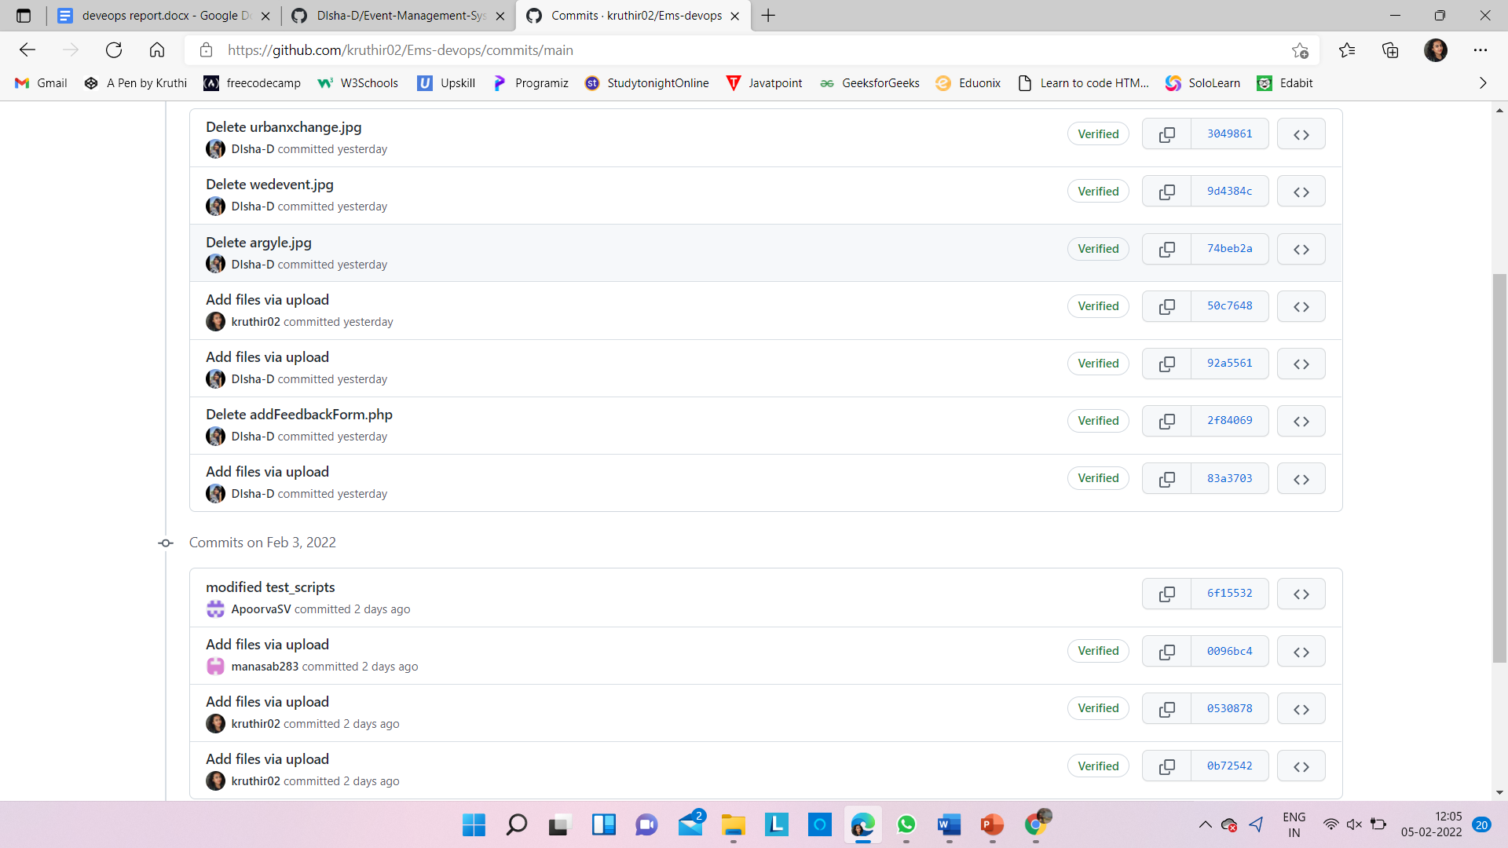

Fig 4.5.3 : History of commits

**5. IMPLEMENTATION OF DEVOPS TOOLS FOR BUILD MANAGEMENT**

**Build automation** is the process of automating the retrieval of source code, compiling it into binary code, executing automated tests, and publishing it into a shared, centralized repository. Build automation is critical to successful **DevOps** processes. With the move to continuous integration and continuous delivery, build management has become an important part of the software development and testing life cycle. Build management is the process of collecting all of the assets to be included in a software release, performing all the automated tasks to compile, build and test the system and then deploy onto the development and testing environments in preparation for staging. The key goals of continuous integration are to find and address bugs quicker, improve software quality, and reduce the time it takes to validate and release new software updates.

**5.1 Tools implemented**

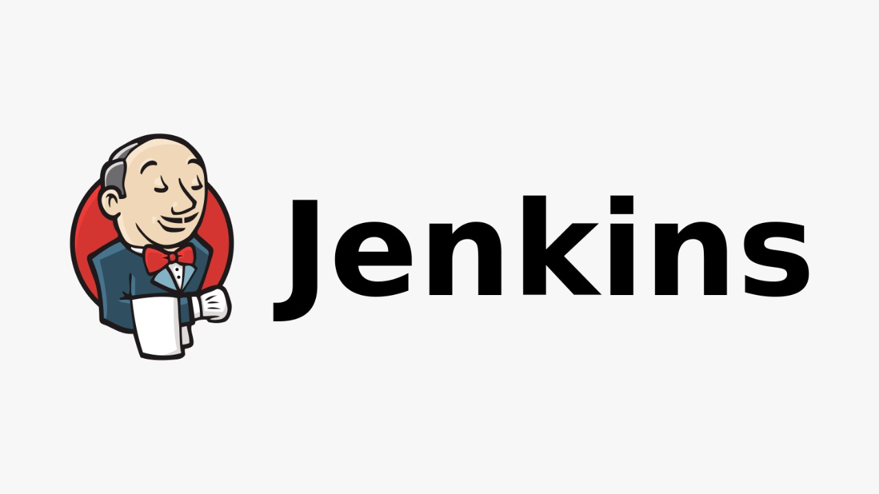

Jenkins is an open source automation server. It helps automate the parts of software development related to building, testing, and deploying, facilitating continuous integration and continuous delivery. It is a server-based system that runs in servlet containers such as Apache Tomcat. Jenkins is an open-source automation tool written in Java with plugins built for Continuous Integration purposes. Jenkins is used to build and test your software projects continuously making it easier for developers to integrate changes to the project, and making it easier for users to obtain a fresh build. It also allows you to continuously deliver your software by integrating with a large number of testing and deployment technologies .

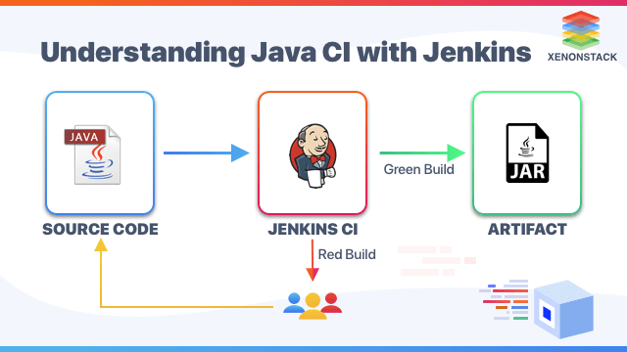

Fig 5.1.1 : Continuous Integration with Jenkins

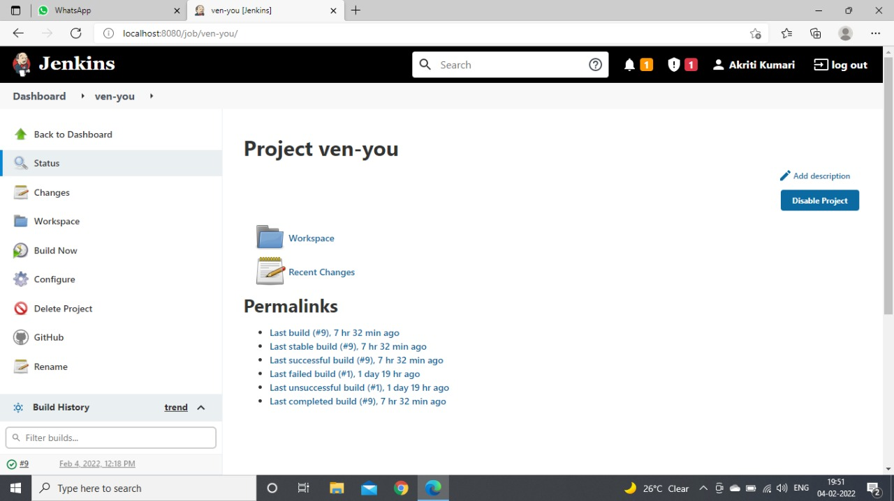

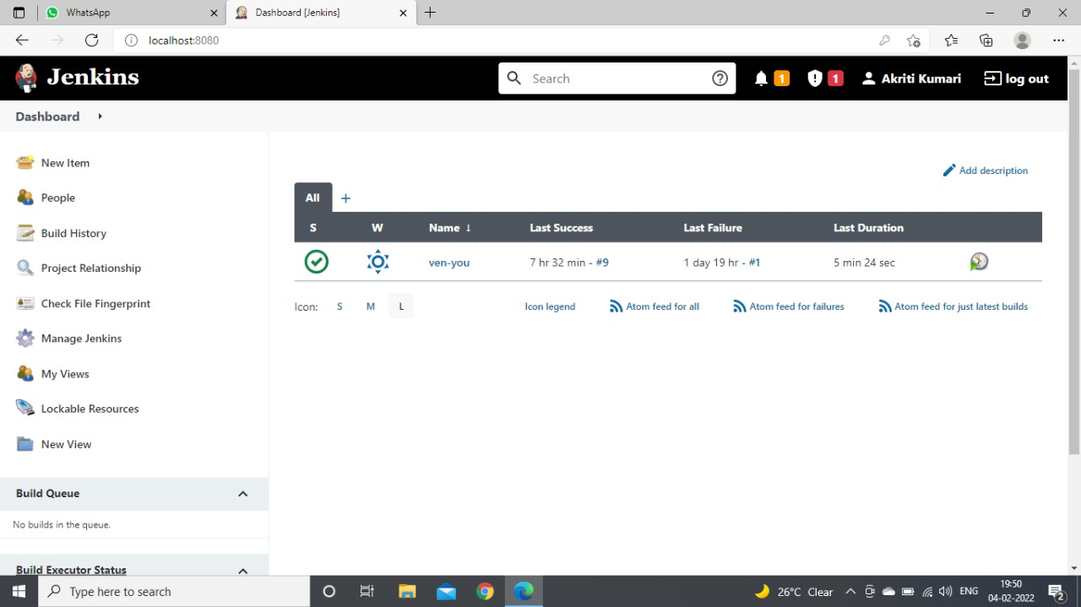

Fig 5.1.2 : History of builds

**5.2 Integration of Build tool**

**5.2.1 Integration with Git**

* Schedule your build
* Pull your code and data files from your GitHub repository to your [Jenkins](https://jenkins.io/) machine
* Automatically trigger each build on the Jenkins server, after each Commit on your Git repository

**Configuring GitHub**

Step 1: go to your GitHub repository and click on ‘Settings’.

Step 2: Click on Webhooks and then click on ‘Add webhook’.

Step 3: In the ‘Payload URL’ field, paste your Jenkins environment URL. At the end of this URL add */github-webhook/*. In the ‘Content type’ select: *‘application/json’* and leave the ‘Secret’ field empty.

Step 4: In the page ‘Which events would you like to trigger this webhook?’ choose *‘Let me select individual events.’* Then, check *‘Pull Requests’* and *‘Pushes’*. At the end of this option, make sure that the *‘Active’* option is checked and click on *‘Add webhook’*.

Step 5: In Jenkins, click on ‘New Item’ to create a new project.

Step 6: Give your project a name, then choose *‘Freestyle project’* and finally, click on *‘OK’.*

Step 7: Click on the ‘Source Code Management’ tab.

Step 8: Click on Git and paste your GitHub repository URL in the ‘Repository URL’ field.

Step 9: Click on the ‘Build Triggers’ tab and then on the ‘GitHub hook trigger for GITScm polling’. Or, choose the trigger of your choice.

GitHub repository is integrated with your Jenkins project. You can now use any of the files found in the GitHub repository and trigger the Jenkins job to run with every code commit.

How to run a python script uploaded to GitHub repository from Jenkins project?

Step 10: Click on the ‘Build’ tab, then click on ‘Add build step’ and choose ‘Execute shell’.

Step 11: To run a python test, simply use the ‘bzt’ command, followed by the name of your YML file and click on ‘Save’.

Step 12: Go back to your GitHub repository, edit the python script and commit the changes. We will now see how Jenkins ran the script after the commit.

Step 13: Go back to your Jenkins project and you'll see that a new job was triggered automatically from the commit we made at the previous step. Click on the little arrow next to the job and choose ‘Console Output’.

Step 14: You can see that Jenkins was able to pull the python script and run it!

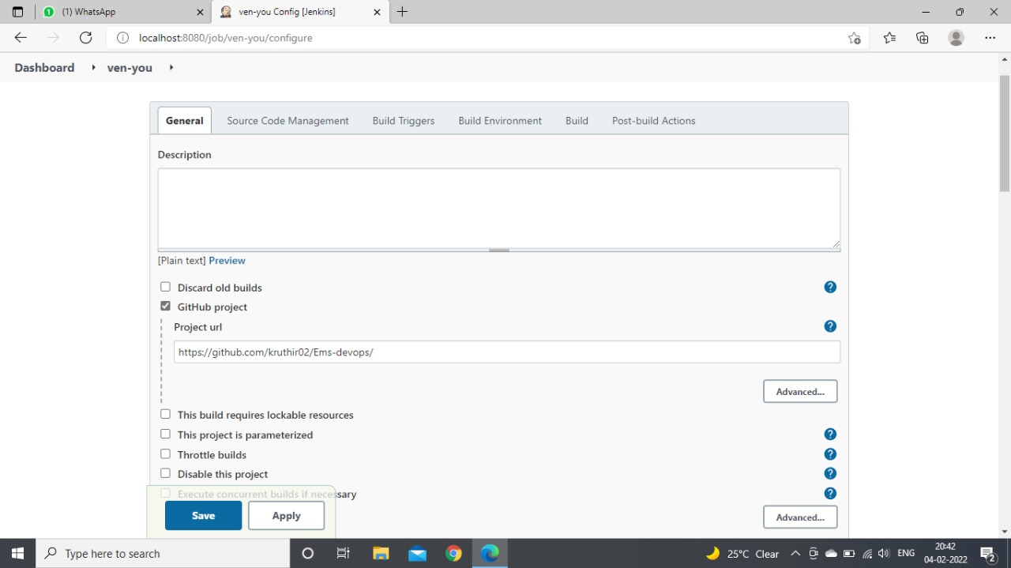

Fig 5.2.1.1 : Integration of Jenkins with Git

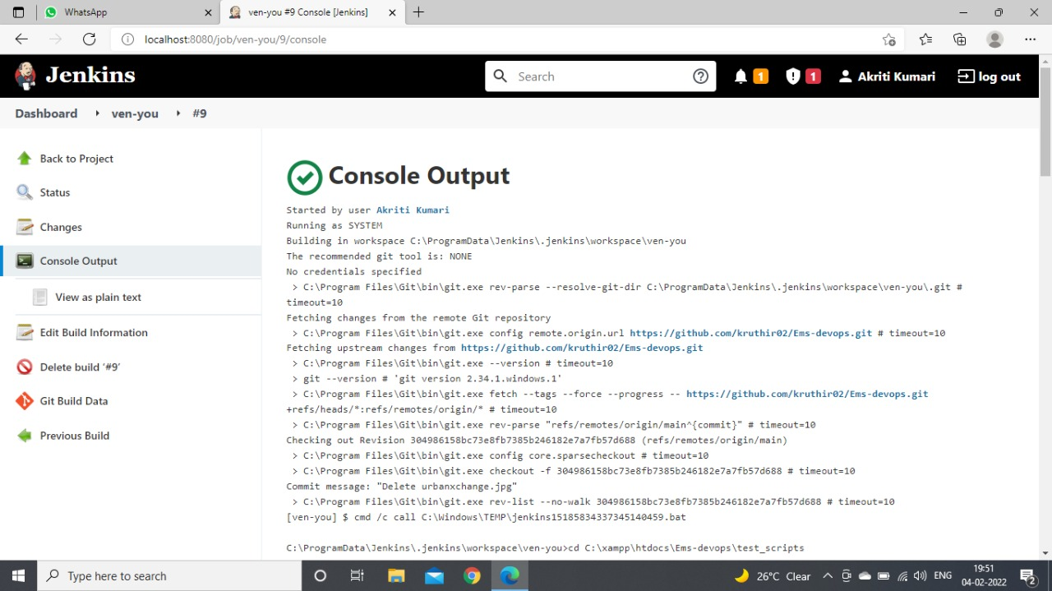

Fig 5.2.1.3 : Console output

**5.2.2 Integration of Jenkins with Selenium**

Step 1: To download Jenkins, you can click the download link on the Jenkins [official website](https://www.jenkins.io/download/). The installation process is explained in detail [here](https://www.lambdatest.com/blog/what-is-jenkins/).

Step 2: Download [Jenkins.war file](http://mirrors.jenkins.io/war-stable/2.235.2/jenkins.war) and place it in the desired path.

Step 3: Open the command prompt and navigate to the folder containing the war file.

Step 4: Enter the command java -jar Jenkins.war. This would start the Jenkins server.

Step 5: Jenkins would usually start in port 8080 by default. In case if the port is being used by any other service, an alternate port can be defined by using the below command

Any available ports can be defined in the above command and can be used to start the Jenkins server.

While starting Jenkins for the first time, a secret password will be generated, which will be printed at the end of the console.

The white shaded part contains the secret password for setting up Jenkins in your machine. When the installation is done successfully, you might see the “Jenkins is fully up and running” message in the console.

Step 6: Launch your browser and navigate to the localhost. By default, the port number would be 8080. In my case, I have defined the port as 8081 and hence use that port while navigating to the localhost.

Now the Jenkins setup page will be launched, which is used for creating the admin account for Jenkins.

Step 7: Enter the secret password that was generated and displayed in the console earlier in the setup page and click Continue.

Step 8: After entering the secret password , you will be asked to install plugins.

If you are not sure of the plugins you want, you can select “Install suggested plugins,” which would install a list of commonly used plugins. But if you know the plugins based on the requirement, you can select the plugins to install option and click the required plugins.

Now the plugins would be downloaded and installed.

Step 9: Once the plugins are installed successfully, you will be asked to create an administrator account by providing a username, password, and email address. Once the admin profile is created, you will be navigated to the Jenkins dashboard.

Now the Jenkins is installed and set up in the localhost, and you will be able to see the Jenkins dashboard.

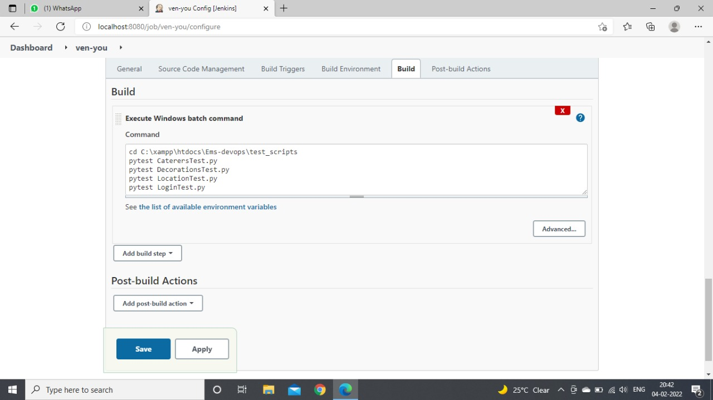

Fig 5.2.2.1 : Integrating Jenkins with Selenium

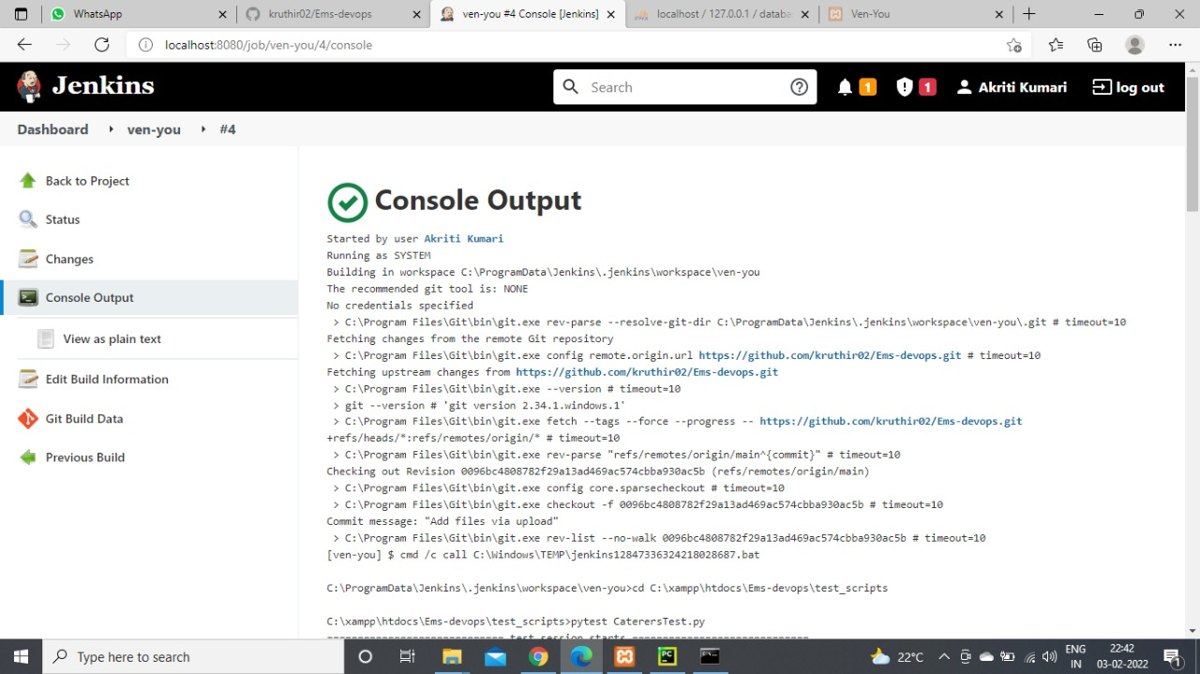

Fig 5.2.2.2 : Output of build after integration with selenium

**5.3 Features of the tools implemented**

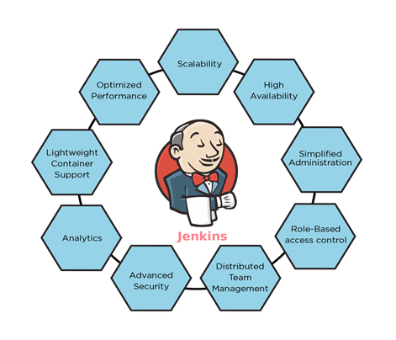

Fig 5.3.1 : Features of Jenkins

### ****Easy Installation :**** Jenkins is a platform-agnostic, self-contained Java-based program, ready to run with packages for Windows, Mac OS, and Unix-like operating systems.

### ****Easy Configuration :**** Jenkins is easily set up and configured using its web interface, featuring error checks and a built-in help function.

### ****Available Plugins :**** There are hundreds of plugins available in the Update Center, integrating with every tool in the CI and CD toolchain.

### ****Extensible :**** Jenkins can be extended by means of its plugin architecture, providing nearly endless possibilities for what it can do.

### ****Easy Distribution :**** Jenkins can easily distribute work across multiple machines for faster builds, tests, and deployments across multiple platforms.

### ****Free Open Source :**** Jenkins is an open-source resource backed by heavy community support.

**List of software artefacts covered in build management tool**

* Importing a GitHub repository for building in Jenkins.
* Additional plugins installation for post build actions.
* Linking Jenkins with selenium for testing.

**5.4 Benefits derived**

* It is free and available to be used with different platforms, such as Windows, Linux, macOS, and others.
* It is widely used, so finding support on online communities is not a big problem.
* Jenkins automates all integration work. Integration issues are scarce, and so, it helps in saving time and money over the project lifecycle.
* It is easy to configure, extend, and modify. It allows the instant generation of tests and building, automation, and deployment of code on different platforms.
* It can easily detect and fix issues. The software is always ready for a sudden release.
* Supports a variety of plugins, which allows better flexibility.
* It helps in detecting errors very early, thus saving developers a lot of time and hard work

**6. IMPLEMENTATION OF DEVOPS TOOLS FOR TEST MANAGEMENT**

**6.1 Tools implemented for testing**

Selenium is an open-source tool that is used for automating the tests carried out on web browsers (Web applications are tested using any web browser). Only Web Applications can be tested using Selenium, Desktop applications and mobile applications cannot be tested.

It provides a single interface that lets you write test scripts in programming languages like Ruby, Java, NodeJS, PHP, Perl, Python, and C#, among others.

We have written the test scripts for our project in Python language. A selenium web driver is installed in any of our favorite GUI for python coding, and testing is performed on the different pages in our website.

**6.2 Scope of testing covered in Test Management tool**

In our project Ven-You website, we have performed testing on only 7 web pages. These Pages are : Login Page, Events page, Locations page, Caterers page, Decorators page, Booking Page, Feedback Page.

All these pages undergo automated testing when the code runs. We have used PyCharm IDE to execute the selenium testing scripts. This process helps us check if able to accept the correct credentials and notify the wrong credentials.

**6.3 Features of the tools implemented**

Open Source and Portable – Selenium is an open source and portable Web testing Framework.

Combination of tool and DSL – Selenium is combination of tools and DSL (Domain Specific Language) in order to carry out various types of tests.

Easier to understand and implement – Selenium commands are categorized in terms of different classes which make it easier to understand and implement

Reduce test execution time – Selenium supports parallel test execution that reduce the time taken in executing parallel tests.

Supports Multiple Browsers – Google Chrome, Mozilla Firefox, Internet Explorer, Edge, Opera, Safari, etc.

Parallel Test Execution – It also supports parallel test execution which reduces time and increases the efficiency of tests.

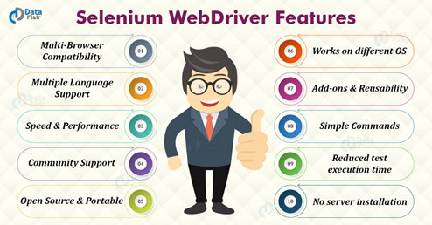

Fig 6.3.1 : Features of Selenium

**6.4 Number of test cases and its automated scripts**

We have written many test scripts. Below are the code screenshots of Successful Login, Failed Login, Booking of an event and feedback.

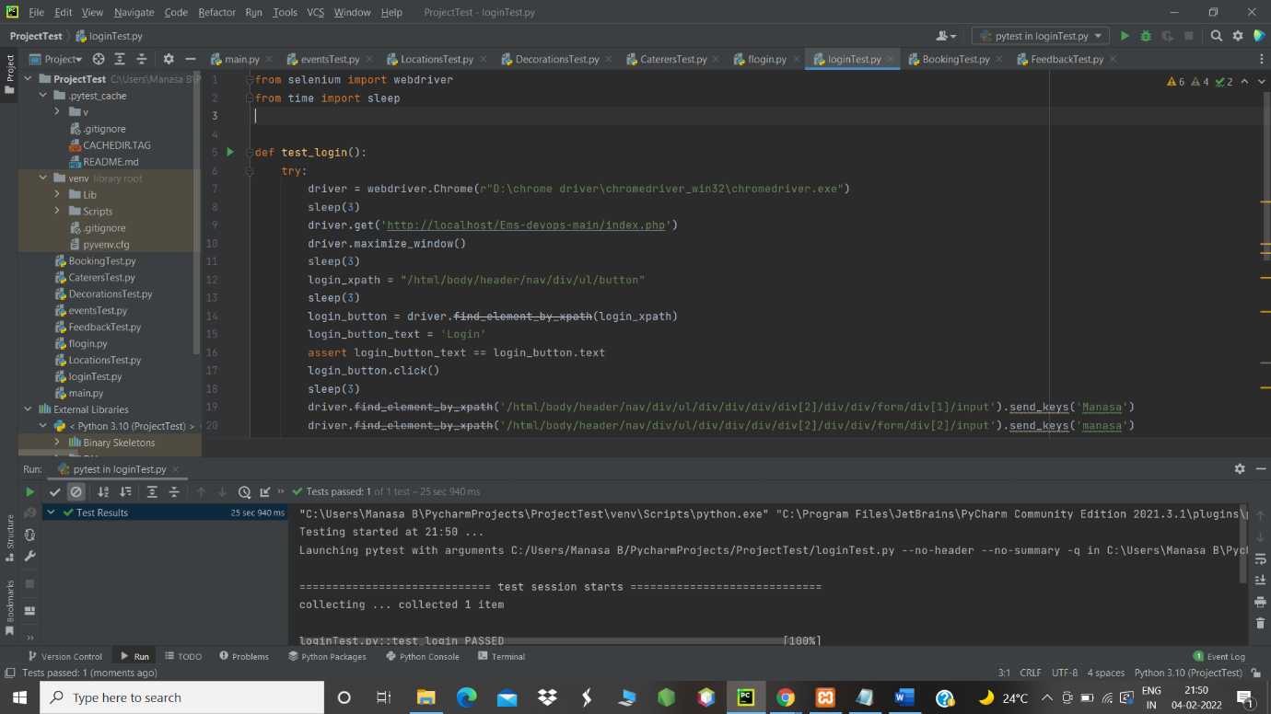

Fig 6.4.1 : Test script for successful login of a page

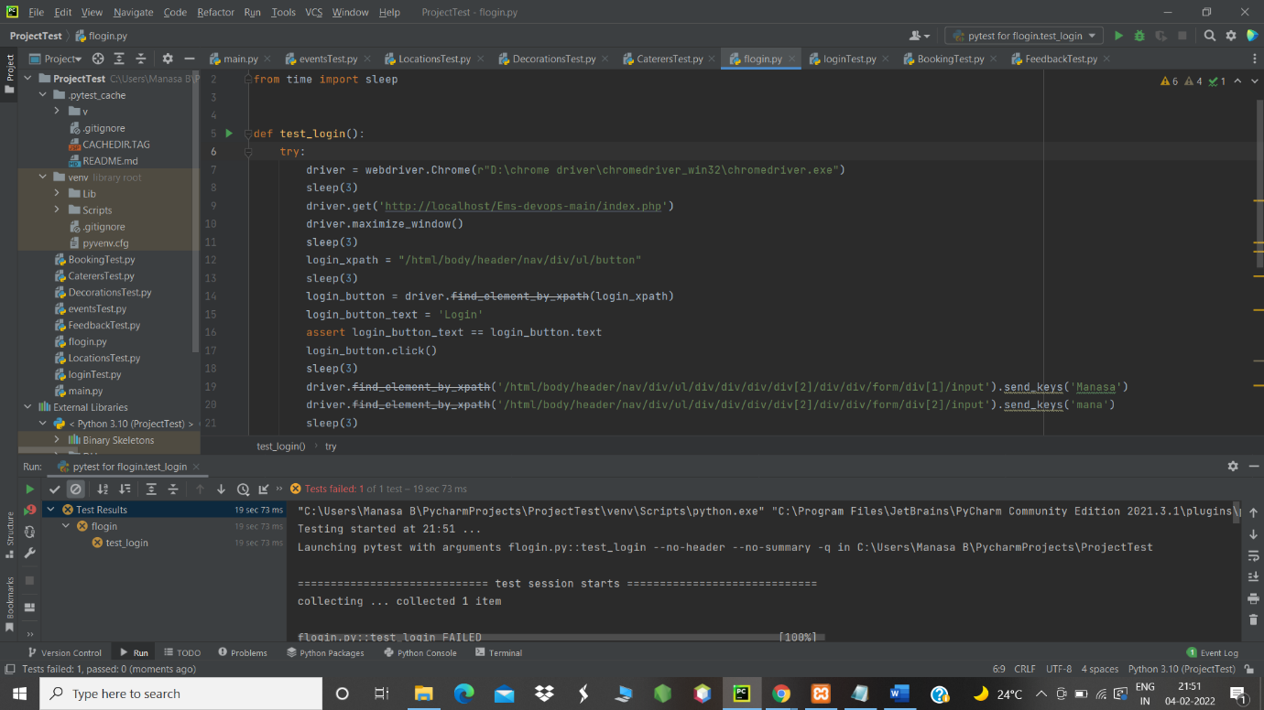

Fig 6.4.2 : Test script for failed login

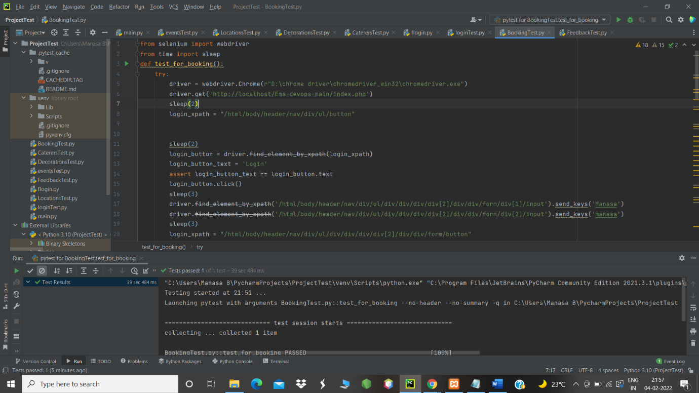

Fig 6.4.3 : Test script to test the booking page

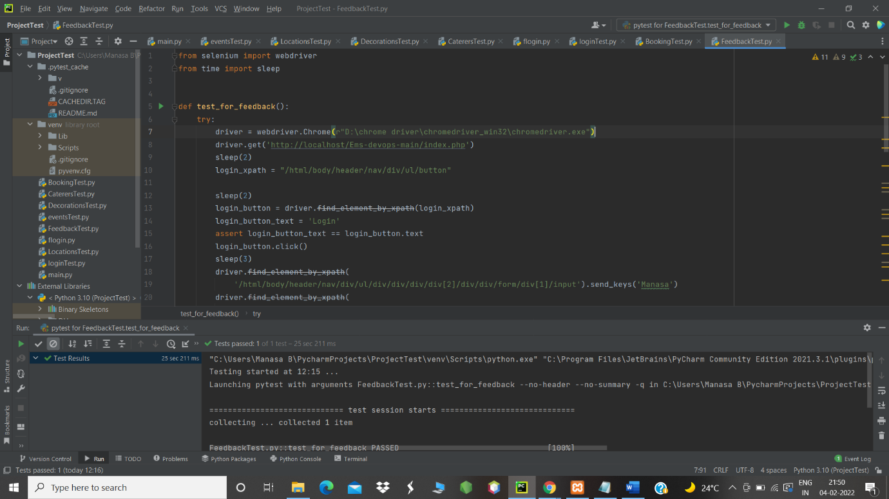

Fig 6.4.4 : Test script to test the feedback page

**6.5 Benefits derived**

* Faster feedback
* Accelerated results
* Reduced business expenses
* Testing efficiency improvement
* Higher overall test coverage
* Reusability of automated tests
* Earlier detection of defects
* Thoroughness in testing
* Faster time-to-market
* Information security

**7. IMPLEMENTATION OF DEVOPS TOOLS FOR DEPLOYMENT**

**7.1 Tools implemented for deployment : Docker**

Docker is a set of platform as a service products that use OS-level virtualization to deliver software in packages called containers. Containers are isolated from one another and bundle their own software, libraries and configuration files; they can communicate with each other through well-defined channels.

It creates containers that packages libraries and dependencies along with it. By using containers everything is packaged. We can just move it and run single command which automatically run all the libraries without conflicting with others.

**7.2 Features of the tools implemented**

* Faster and easier configuration
* Application isolation
* Increase in productivity
* Swarm
* Services
* Routing Mesh
* Security Management
* Rapid scaling of Systems
* Better Software Delivery
* Software-defined networking
* Has the Ability to Reduce the Size

**7.3 Number and nature of deployments**

1. Install Docker on the machines you want to use it
2. Set up a registry at Docker Hub
3. Initiate Docker build to create your Docker Image
4. Set up your ’Dockerized‘ machines
5. Deploy your built image or application

**7.4 Docker usage in our project**

Containerizing our application with docker begins with the process of creating a Docker Image. A Docker Image is a read-only template that packages everything needed for our application. This includes the runtime, application source code, application specific dependencies, system libraries and commands to configure and run your application. Docker uses these images to run Docker Containers. These containers are isolated environments that run our application. Simply put, a container is an instance of a docker image running our application.

There are two containers in our project - One for php and other for MySQL. We can run the container and open the website through the containers. We have also pushed and committed the Docker image of our project to Docker hub.

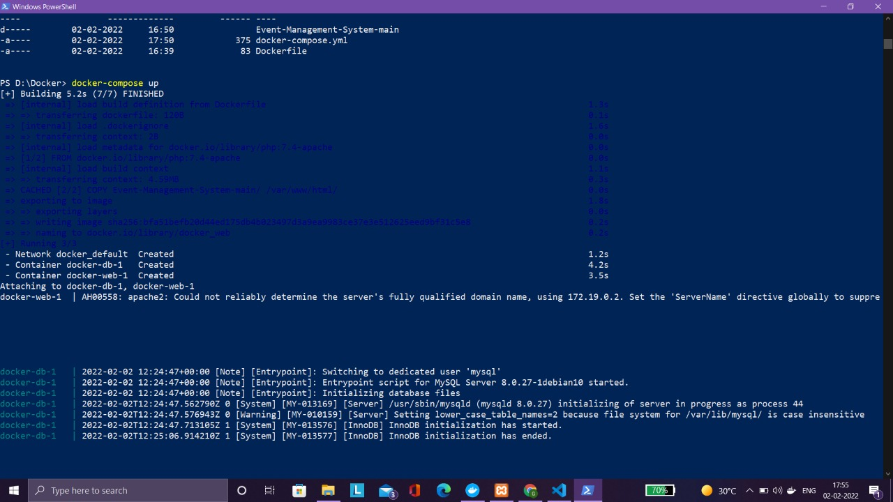

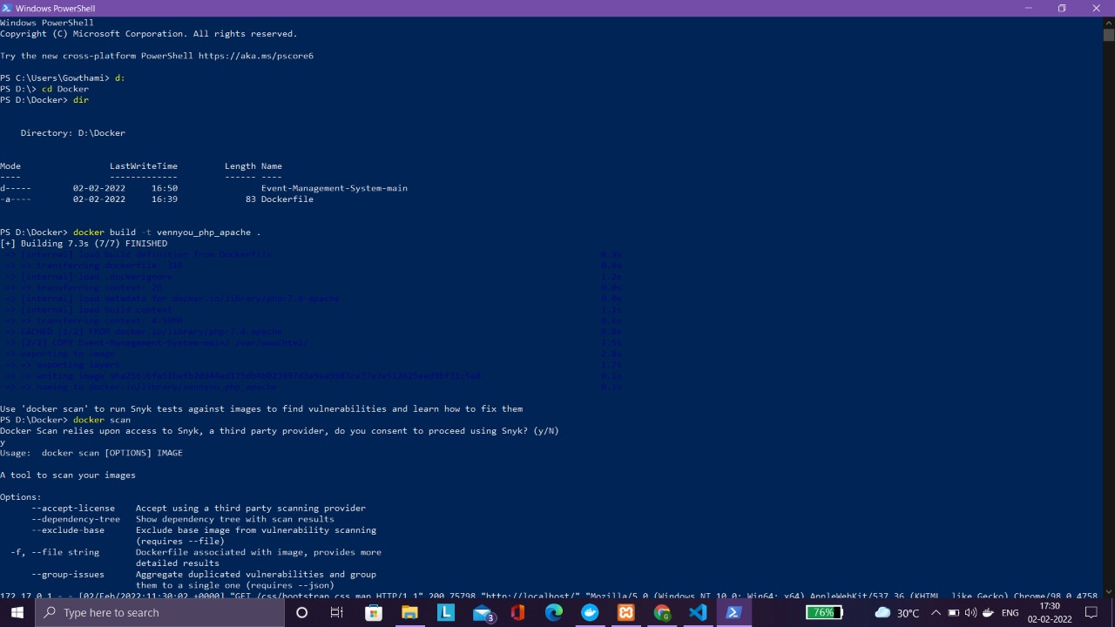

Fig 7.4.1 Open the directory where our php project, Docker file and docker compose.yml files are stored and building the image

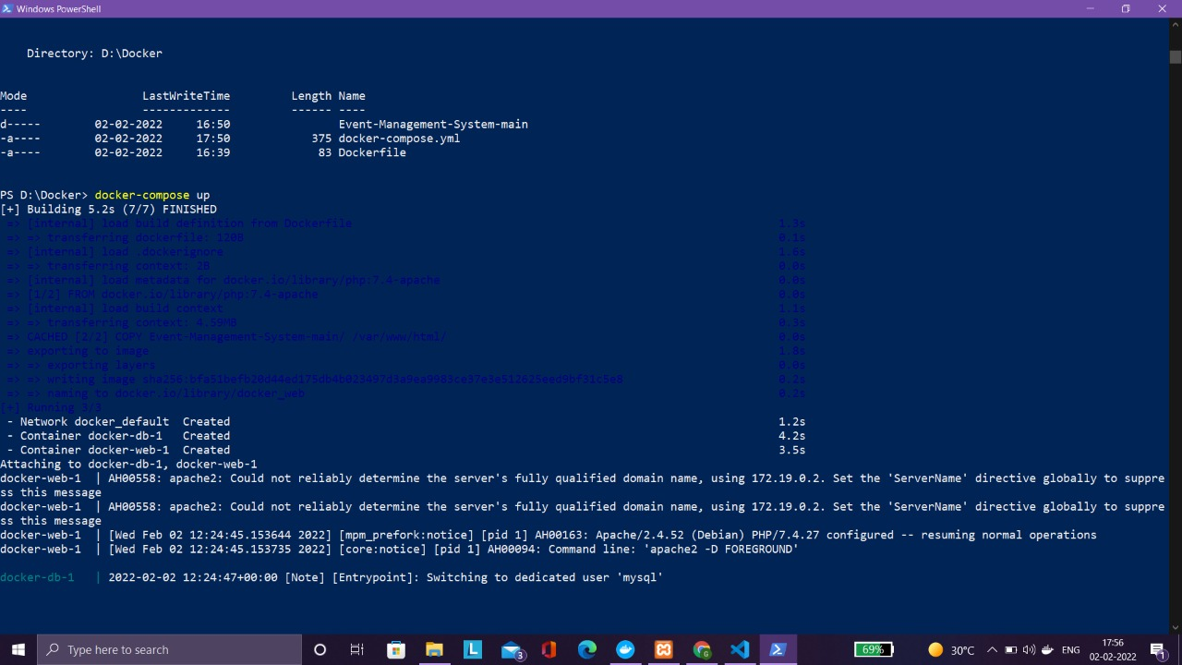

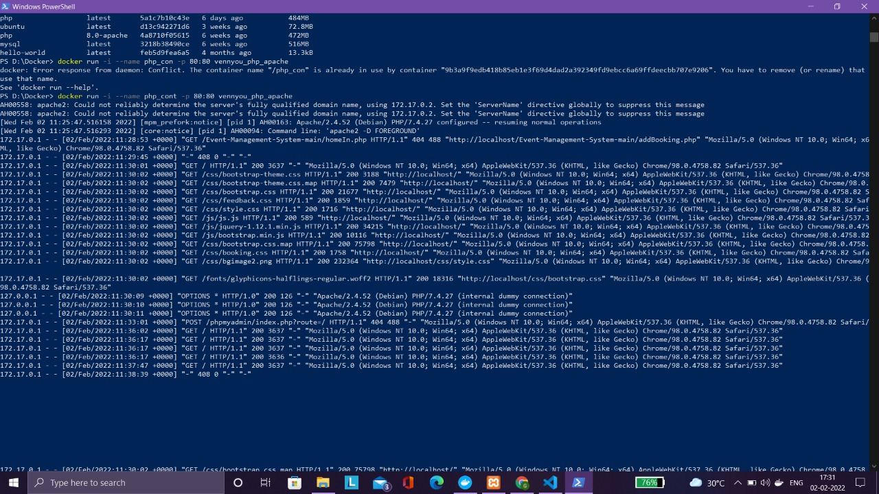

Fig 7.4.2 : Running the created container

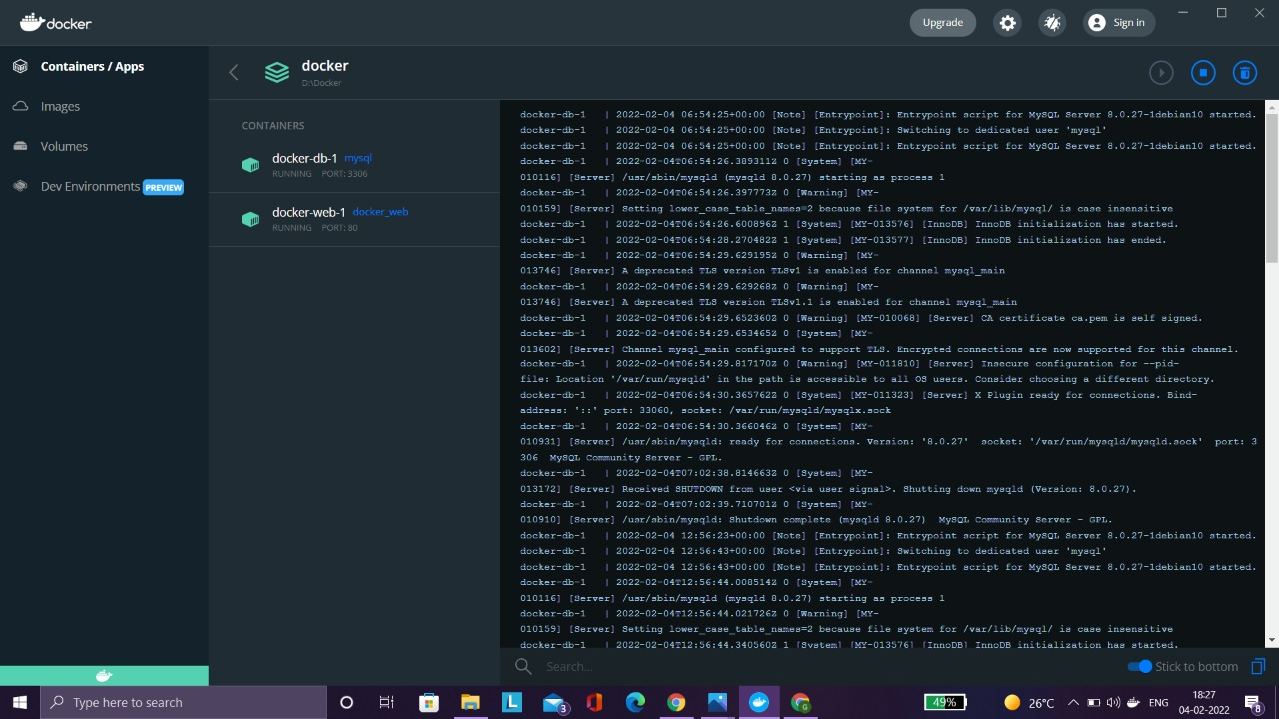

Fig 7.4.3 : Two containers are created and are running in port 80

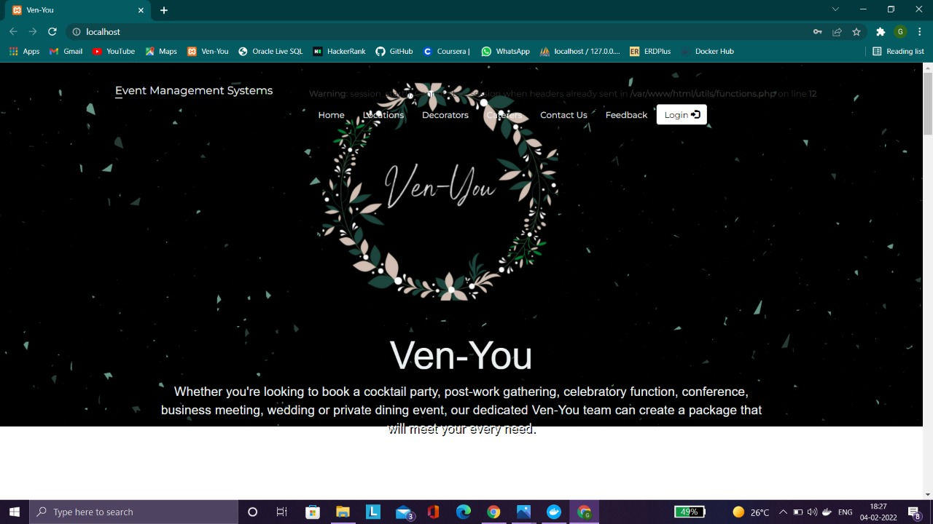

Fig 7.4.4 : Opening website through container

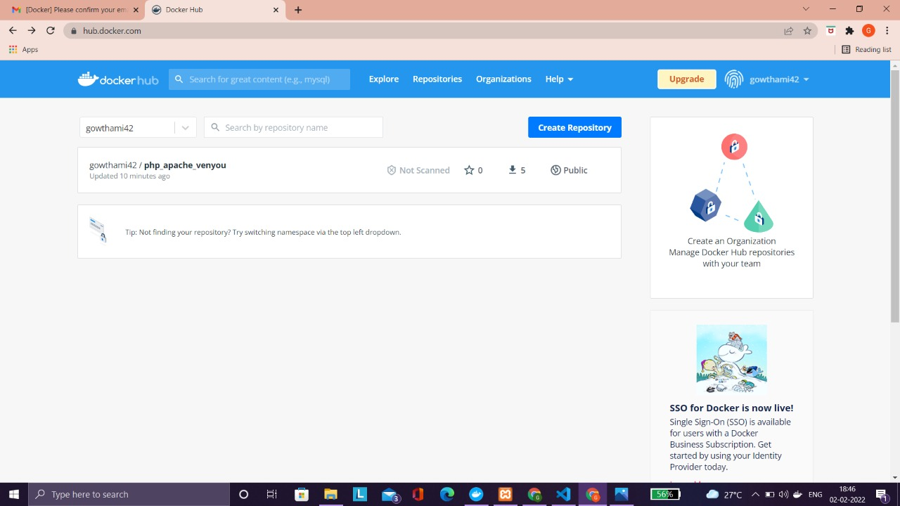

Fig 7.4.5 : Docker image pushed and committed to Docker hub

**7.4 Benefits derived**

Containerization has become an efficient way of boosting productivity in IT development processes. As the market keeps growing, people want explore the biggest Docker benefits and they want to know more about this valuable tool.

1. Consistent and Isolated Environment

2. Cost-effectiveness with Fast Deployment

3. Mobility – Ability to Run Anywhere

4. Repeatability and Automation

5. Test, Roll Back and Deploy

6. Test, Roll Back and Deploy

7. Flexibility

8. Collaboration, Modularity and Scaling

**8. IMPLEMENTATION OF AGILE PRACTICES**

**8.1 Introduction to Agile**

Agile is an iterative approach to project management and software development that helps teams deliver value to their customers faster and with fewer headaches. Instead of betting everything on a "big bang" launch, an agile team delivers work in small, but consumable, increments. Requirements, plans, and results are evaluated continuously so teams have a natural mechanism for responding to change quickly.

Whereas the traditional "waterfall" approach has one discipline contribute to the project, then "throw it over the wall" to the next contributor, agile calls for collaborative cross-functional teams. Open communication, collaboration, adaptation, and trust amongst team members are at the heart of agile. Although the project lead or product owner typically prioritizes the work to be delivered, the team takes the lead on deciding how the work will get done, self-organizing around granular tasks and assignments.

Agile isn't defined by a set of ceremonies or specific development techniques. Rather, agile is a group of methodologies that demonstrate a commitment to tight feedback cycles and continuous improvement.

**8.2 Agile Practices Implemented in our project**

### 1. Iterative Development : Through [agile iterative development](https://www.ntaskmanager.com/blog/what-is-agile-iterative-approach/), bigger projects are broken down into smaller chunks and continuous tests are done in repetitive cycles. Through this practice, agile teams get a perspective on new features that need to be added to the final product or service and contribute towards more flexible product development.

### 2. Regular Meetings : Regular meetings are key to agile implementation. These meetings should be short and concise, with each member of the team explicitly stating the progress of tasks and what needs to be done. This practice is a great way to monitor the performance of the team and check if there are any obstacles in the way of product development.

### 3. Using Professional Tools : Using [project management tools](https://www.ntaskmanager.com/blog/free-project-management-tools/) for the implementation of agile methodology helps the team to better structure their workflows and [improve team collaboration](https://www.ntaskmanager.com/blog/best-team-collaboration-software/). For proper documentation and meetings management, professional project management software can greatly reduce the effort it takes to manage your tasks otherwise.

## 8.3 Product Backlog

In Agile development, a product backlog is a prioritized list of deliverables (such as new features) that should be implemented as part of a project or product development. It's a decision-making artifact that helps you estimate, refine, and prioritize everything you *might sometime in the future*want to complete.

It helps ensure the team is working on the most important and valuable features, fixing the most important bugs, or doing other important work critical to product development.

The backlog, therefore, is tremendously useful in situations when you are unable to do everything being asked (so, most situations), or in contexts when even a small amount of planning will help a lot (so, in most contexts).

The purpose of the backlog can be reduced to three simple goals.

* Develop a common ground to align stakeholders and teams, so that teams implement the most valuable user stories.
* Provide flexibility to adapt to new needs and realities.
* Improve the accuracy of product release forecasts by creating a common denominator across many teams collaborating on one product.

For our project we have analysed the tasks to be performed and have a finalized list of 77 tasks that had to be executed.

|  |  |  |
| --- | --- | --- |
| **ITEM** | **DESCRIPTION** | **BY** |
| 1. | Finalizing the software used | All |
| 2. | Deciding the name of the website : Ven-you |
| 3. | Grouping of teams / formation of sub-teams |
|  | **Software used** |
| 4. | Version control - GitHub |
| 5. | Container Management tools - Kubernetes |
| 6. | CI / Deployment Automation tools - Jenkins |
| 7. | Test Automation Tools - Selenium |
| 8. | Frontend - HTML, CSS, JS |
| 9. | Backend - PHP, XAMPP |
| 10. | Database - MYSQL |
| 11. | Formation of sub teams |
| 12. | Assigning each sub-team a task |
| 13. | Deciding the events to be listed |
| 14. | Deciding the venues to be listed |
| 15. | Deciding the languages to be used |
| 16. | Deciding the tools to be used |
| 17. | Designing the logo |
| 18. | Deciding the website layout |
| 19. | Deciding in scope and out of scope requirements |
|  | **Frontend** |
| 20. | Login page for user | KR |
| 21. | User Id and password for user login | AS |
| 22. | Registration page for new user | AV |
| 23. | Obtaining details of new user and storing it | GH |
| 24. | Details of each event | MB |
| 25. | Home page | AJ |
| 26. | Inserting images on home page | AK |
| 27. | Providing contact details on home page | AP |
| 28. | Creation and insertion of images and logo on home page | DD |
| 29. | Creating the list of events | AJ |
| 30. | Creating list of venues | KR |
| 31. | Details about each venue | AP |
| 32. | Deciding the services offered | AS |
| 33. | Briefing about each event | MB |
| 34. | Events – Birthday, Housewarming, Engagement, Marriage, Baby shower, Naming ceremony | GH |
| 35. | Services offered – catering, venue, decoration, band |
| 36. | Pages for each of the services | KR |
| 37. | Themes | MB |
| 38. | Feedback page | AK |
| 39. | Adding Contact details | AV |
| 40. | Detailed description of each event | KR |
| 41. | Booking page for the events | DD |
| 42. | Giving details about caterer | AP |
| 43. | Page containing food styles offered | AK |
| 44. | Details about the decorators | AJ |
| 45. | Page containing decor styles offered | GH |
| 46. | Creation of booking form | MB |
| 47. | Creation of feedback form to collect review of users | AV |
| 48. | List to display already booked venues with dates | KR |
| 49. | Display of previous reviews to all users | DD |
|  | **Backend** |  |
| 50. | Creating tables for users | AK |
| 51. | Table for events, locations, caterers, decorators | MB |
| 52. | Creating tables for feedback, booking | GH |
| 53. | Connecting frontend to database | AS |
| 54. | Creating backend functionality pages for feedback and booking | KR |
| 55. | Connecting the backend with the database | DD |
| 56. | Accepting the feedback from user | AK |
|  | **Database** | MB |
| 41. | Defining the number of tables used |
| 42. | Deciding the attributes in each table | AS |
| 43. | Designing the tables | MB, AS |
| 44. | Inserting values into tables | MB, AS |
| 45. | Connecting frontend and backend | KR |
|  | **DevOps Tools** | KR, DD, AP |
|  | **GitHub: Version control** |
| 46. | Install the tool : GitBash |
| 47. | Learn the working and features of Git |
| 48. | Create a repository |
| 49. | Add contributors to the repository |
| 50. | Push all created files to the repository |
| 51. | Integrate Git with Jenkins |
| 52. | Create branches |
| 53. | Push all remaining files to repository |
| 54. | Get test scripts from Selenium and push them to the repository |
|  | **Jenkins : Build tool** | AK, AJ |
| 55. | Install Jenkins |
| 56. | Create a job |
| 57. | Integrate Git with Jenkins |
| 58. | Integrate Selenium with Jenkins |
| 59. | Build the files |
| 60. | Trying to fix the bugs |
|  | **Selenium : Testing tool** |  |
| 61. | Install the selenium software | MB, AS |
| 62. | Integrate Selenium with Jenkins |
| 63. | Write test scripts for testing the navigation to different pages |
| 64. | Test scripts to enter data for booking and contact pages |
| 65. | Creating test scripts to test button functionality |
| 66. | Testing navigation between pages |
| 67. | Testing the register function |
| 68. | Test the login by different users |
| 69. | Test scripts for booking an event |
| 70. | Testing the feedback functionality |
|  | **Docker : Container management tool** | GH, AV |
| 71. | Install docker software |
| 72. | Learn the working of docker |
| 73. | Create containers for php and Apache |
| 74. | Have the knowledge of basic commands to create and delete containers and images |
| 75. | Create Docker file and docker-compose.yml |
| 76. | Create containers for the project |
| 77. | Run the container on the web |

**Scrum Master: Kruthi R Aithal (KR)**

**Product Owner: Disha D (DD)**

Gowthami Holla (GH) Avani K S (AV)

Anitha P (AP) Apoorva S V (AS)

Manasa B Reddy (MB) Aishwarya J Annigeri (AJ)

Akriti Kumari (AK)

**8.4 Scrums**

Scrum is a framework that helps teams work together. Much like a rugby team (where it gets its name) training for the big game, scrum encourages teams to learn through experiences, self-organize while working on a problem, and reflect on their wins and losses to continuously improve.

Scrum is most frequently used by software development teams; its principles and lessons can be applied to all kinds of teamwork. This is one of the reasons scrums are so popular. Often thought of as an agile project management framework, scrum describes a set of meetings, tools, and roles that work in concert to help teams structure and manage their work.

Scrum is a framework for getting work done, where [agile](https://www.atlassian.com/agile) is a mindset. You can’t really “go agile”, as it takes dedication from the whole team to change the way they think about delivering value to your customers. But you can use a framework like scrum to help you start thinking that way and to practice building agile principles into your everyday communication and work.

The scrum framework is heuristic; it’s based on continuous learning and adjustment to fluctuating factors. It acknowledges that the team doesn’t know everything at the start of a project and will evolve through experience. Scrum is structured to help teams naturally adapt to changing conditions and user requirements, with re-prioritization built into the process and short release cycles so your team can constantly learn and improve.

In our project we had a total of 4 scrums with each scrum having a duration of 2 weeks.

The first scrum was dedicated to making important decisions about the project, deciding the software used and tools to be implemented. The second scrum had tasks mostly related to frontend development and database designing. The scrum focused more on DevOps tools installation and learning their usage along with a little focus on frontend development and main focus on backend development. The last scrum was focused on DevOps tools and implementation of those tools.

The scrums are attached below.

|  |  |  |
| --- | --- | --- |
|  | **DESCRIPTION** | **EST** |
| **Scrum 1** |  | 2 weeks |
| 1. | Deciding the title of project | Done by everyone |
| 2. | Finalizing the software used |
| 3. | Deciding the name of the website |
| 4. | Formation of sub teams |
| 5. | Assigning each sub-team a task |
| 6. | Deciding the events to be listed |
| 7. | Deciding the venues to be listed |
| 8. | Deciding the languages to be used |
| 9. | Deciding the tools to be used |
| 10. | Designing the logo |
| 11. | Deciding the website layout |
| 12. | Deciding in scope and out of scope requirements |

Table 8.4.1 : Scrum 1

|  |  |  |
| --- | --- | --- |
|  | **DESCRIPTION** | **EST** |
| **Scrum2** |  |  |
|  | **Frontend** | 2 weeks |
| 1. | Login page for user | KR |
| 2. | Registration page for new user | AJ |
| 3. | Obtaining details of new user and storing it | AP |
| 4. | Details of each event | AK |
| 5. | Creation and insertion of images and logo on home page | DD |
| 6. | Creating the list of events | AV |
| 7. | Creating list of venues | KR |
| 8. | Details about each venue | DD |
| 9. | Deciding the services offered | GH |
| 10. | Feedback page | AP |
|  | **Backend** |  |
| 11. | Designing the tables | MB , AS |
| 12. | Defining attributes used in the database | GH,AV |
| 13. | Defining relationships and constraints | AK,AJ |

Table 8.4.2 : Scrum 2

|  |  |  |
| --- | --- | --- |
|  | **DESCRIPTION** | **EST** |
| **Scrum3** |  | **2 weeks** |
|  | **Website** |  |
| 1. | Adding Contact details | AP |
| 2. | Detailed description of each event | GH |
| 3. | Booking page for the events | AJ |
| 4. | Creating tables for contact, feedback, booking | KR |
| 5. | Connecting frontend to database | DD |
| 6. | Creating backend functionality pages for feedback and booking | AV |
| 7. | Connecting the backend with the database | AK |
|  | **DevOps Tools** | KR , DD, AP |
|  | **Git** |
| 10. | Install the tool : GitBash |
| 11. | Learn the working and features of Git |
| 12. | Create a repository |
| 13. | Add contributors to the repository |
| 14. | Push all created files to the repository |
| 15. | Integrate Git with Jenkins | GH, AV |
|  | **Docker** |
| 16. | Install docker software |
| 17. | Learn the working of docker |
| 18. | Create containers for php and apache |
| 19. | Have the knowledge of basic commands to create and delete containers and images |
| 20. | Create dockerfile and docker-compose.yml |
|  | **Jenkins** | AJ, AK |
| 21. | Install Jenkins |
| 22. | Create a job |
| 23. | Integrate Git with Jenkins |
| 24. | Integrate Selenium with Jenkins |
| 25. | Build the files |
| 26. | Trying to fix the bugs |
|  | **Selenium** | MB, AS |
| 27. | Install the selenium software |
| 28. | Integrate Selenium with Jenkins |
| 29. | Write test scripts for testing the navigation to different pages |
| 30. | Test scripts to enter data for booking and contact pages |

Table 8.4.3 : Scrum 3

|  |  |  |
| --- | --- | --- |
|  | **DESCRIPTION** | **EST** |
| **Scrum4** |  | **2 weeks** |
|  | **Frontend** |  |
| 1. | Giving details about caterer | KR |
| 2. | Page containing food styles offered | AJ |
| 3. | Details about the decorators | AP |
| 4. | Page containing decor styles offered | GH |
| 5. | Creation of booking form | DD |
| 6. | Creation of feedback form to collect review of users | AV |
| 7. | List to display already booked venues with dates | AK |
| 8. | Display of previous reviews to all users | GH |
|  | **GitHub** |  |
| 9. | Create branches | KR, DD, AP |
| 10. | Push all remaining files to repository |
| 11. | Get test scripts from Selenium and push them to the repository |
|  | **Docker** | GH, AV |
| 12. | Create containers for php, Apache |
| 13. | Create docker compose and docker yml files |
| 14. | Create containers for the project |
| 15. | Run the container on the web |
|  | **Jenkins** | AK, AJ |
| 16. | Integrate Jenkins with Selenium |
| 17. | Integrate Git with Selenium |
| 18. | Build the updated files with test scripts |
|  | **Testing** | MB, AS |
| 19. | Creating test scripts to test button functionality |
| 20. | Testing navigation between pages |
| 21. | Testing the register function |
| 22. | Test the login by different users |
| 23. | Test scripts for booking an event |
| 24. | Testing the feedback functionality |

Table 8.4.4 : Scrum 4

**8.5 Scrum practices used**

**1. Create Product Backlog in conjunction with Product Owner.**

The product owner can contribute effectively to creating the product vision, and must be roped in for the inputs while creating the product backlog. During the negotiations on the backlog and while re-prioritising tasks, the team and product owner can come to a better understanding of the vision and what is expected to be delivered.

**2. Holding regular Scrum meetings**

When team members and Product Owners participate in Scrum meetings, they will understand the workflow and the ways in which the team works. In turn, they can offer valuable feedback on the progress of work and about the deliverables during each sprint.

**3. Plan a new sprint only when the backlog has enough items.**

Only when the product backlog has enough items for the next two sprints, is it time to plan the next one. Scope creep happens when there is uncontrolled growth in the scope of the project, because there was poorly defined scope for the next few sprints in the backlog.

**4. Keep sprint backlog separate from product backlog.**

The product backlog is updated regularly, while the sprint backlog is kept frozen and can be referred back to at any time. Do not mix up the two or combine them.

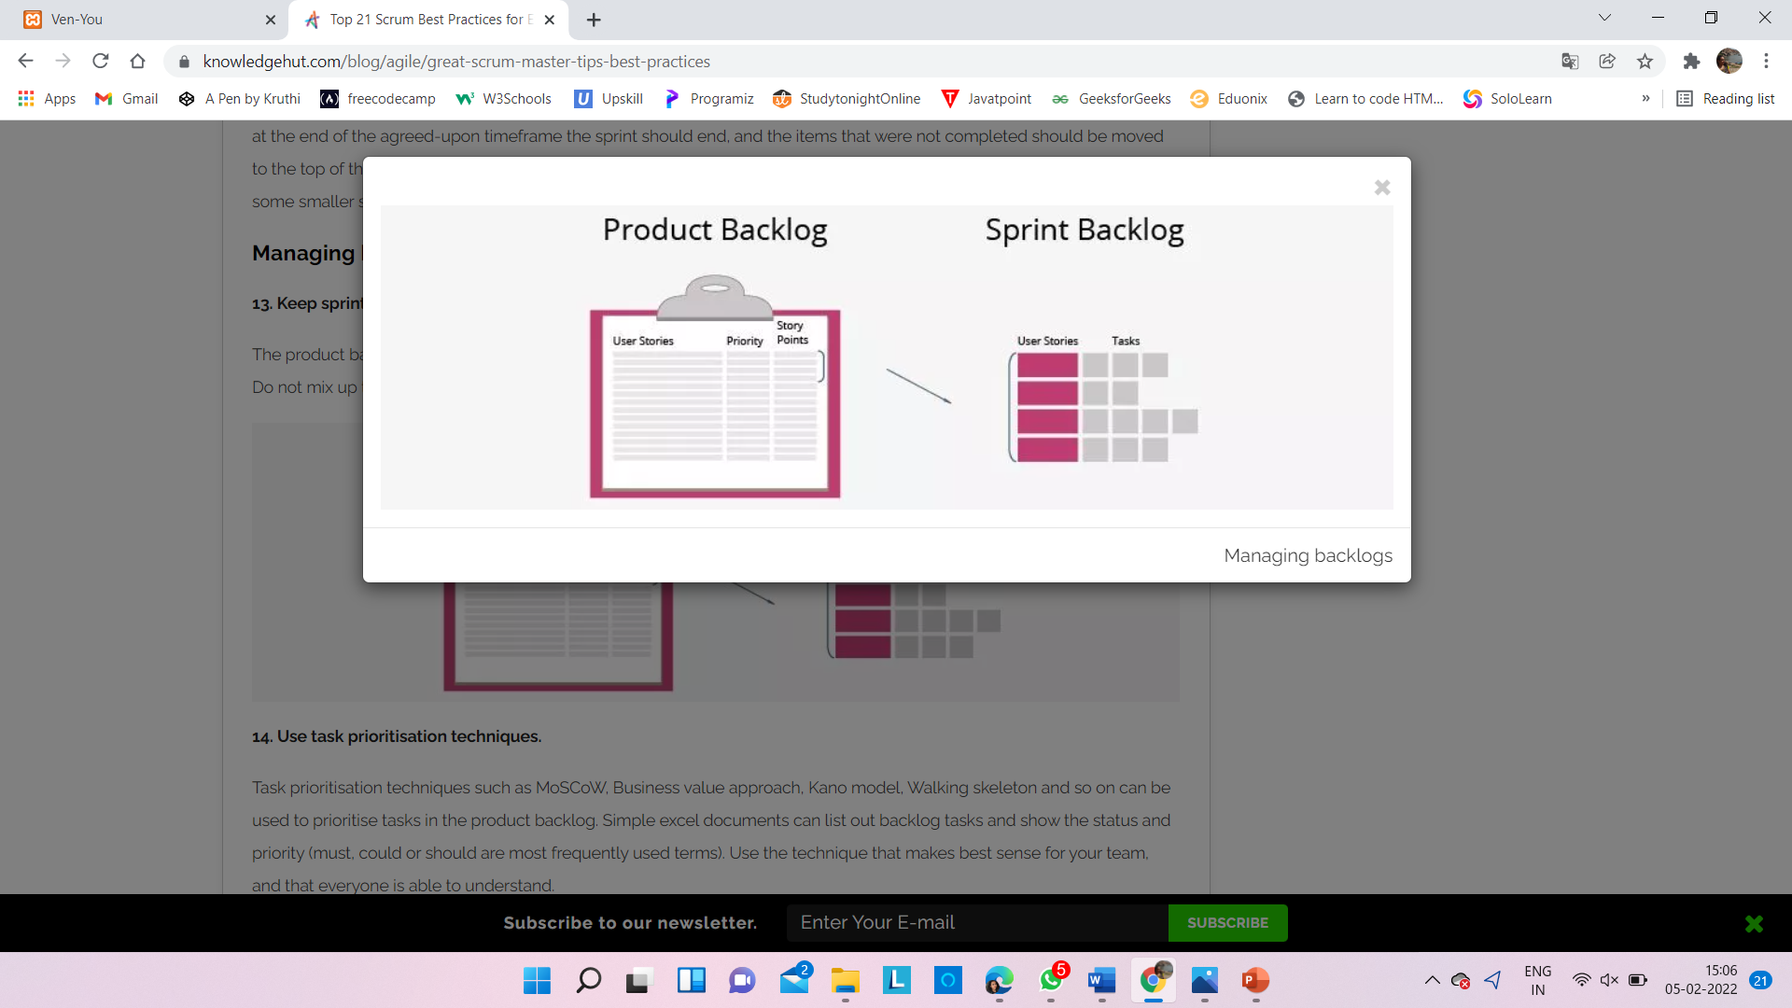

**5. Chart velocity.**

By calculating the velocity, the progress of work can be charted against initial estimates, and used to better predict team commitments and results. If the velocity is changing a great deal, then the sprint planning must be revisited and made more reliable.

The below graph represents the velocity metrics for our project for all the 4 scrums.

**8.5 Benefits of adopting Agile practices**

1. Superior quality product
2. Customer satisfaction
3. Better control
4. Improved project predictability
5. Reduced risks
6. Increased flexibility
7. Continuous Improvement
8. More relevant metrics

**9. CONCLUSION AND FUTURE SCOPE**

Event management, the most profound form of advertising and marketing, is a glamorous and thrilling profession. It provides an opportunity for unleashing one's creative potential to a very high degree. It demands a lot of hard work and effort but at the same time offers enormous scope.